Web Design and Development

4COSC011C.3

Report

Author: S. Gokula Nandhan

Student ID: 20233027

Group Number: C-1

Group Name: Fit Glow

Student Role: No.01

Contents

1. Introduction 3

1.1 Team Members and Task Allocation 3

1.2 Website topic/theme 4

1.3 Contributions 4

1. Technical Discussion 5

1.1 Implementation 5

1.2 Task completion checklist 6

2 Webpage Validation Statement 7

3 Janet 7

4 Self-reflection 7

References 8

Appendices 9

Appendix A: Code 9

Appendix B: Screenshots 42

Appendix C: Screenshots - Webpage Validation Evidence 53

Appendix D: Task Completion Checklist 55

# Introduction

## 

## The module leader, Mrs. Dileeka Alwis, has tasked students with group course work for the module of website design and development. It was mainly focused on understanding the fundamental concepts of HTML, CSS, and JavaScript, the implications of the relevant basics, team spirit, and the task management of the team members. The complimented task is ,the University of Westminster is mainly to focus on sustainable development for the students and colleagues to produce a sustainable and healthier society in the future. So they adopted the United Nations Sustainable Development Goals (SDGs).

## Framework to support this core mission and to record, measure, and improve our contribution to a range of social, environmental, and economic outcomes. There are seventeen main goals available from the SDGs. One of the main goals will be to create a theme for the coursework and implement a relevant webpage. So our group has chosen the theme “Good health and well-being.”.

“Good health and well-being” are essential to everyone who lives on earth. The SDG is promoting the main moral of the theme, which is “to ensure healthy lives and promote well-being for all at all ages." A healthy lifestyle for a modern human is a less contemplated thing for themselves. The topic covers the various paths to a healthy lifestyle, such as healthy Life cycle, disease protection, social awareness, sustainability of all ages, etc.

 Our web application provides a relevant topic covering those common factors of good health, and it has a lot of features to connect with the web application. As a part of our contribution, we focused on healthy lifestyle needs, the ongoing culture of the world, promotion of wellbeing, and technical needs like user-friendly web sites, well-implemented structure patterns, and good code quality. As my contribution, I am fully potential to put a very good outcome on the website.

## Team Members and Task Allocation

**Student 1 : S.Gokula Nandhan**

1.Splash Screen

2.Shop

3.Content Page

4.Page editor

**Student 2 : H.Thilaksha Lakshan**

1.Home page(Navigation Bar, Footer)

2.Feed back

3.Content Page

4.Page editor

**Student 3 : S.Thibakar**

1.User profile

2.Team

3.Content Page

4.Page Editor

**Student 4 : S.Thenujaa**

1.Gallery

2.Sitemap

3.Content Page

4.Page editor

## 1.2 Website topic/theme

The primary focus of the topic "Good health and well-being" is on the health care of all individuals, from young children to elderly people, at every stage of life.

## 1.3 Contributions

| **Group Coursework Meetings** | | |
| --- | --- | --- |
| **1** | **Date & Time** | **04th July 2024** |
| **Objective:** | **Selected the website theme and name** |
| **Attended:** | **Everyone Attended** |
| **Your Contribution:** | **Shares the ideas about the topic** |
| **2** | **Date & Time:** | **05th July 2024** |
| **Objective:** | **Provide ideas to design the website** |
| **Attended:** | **Everyone Attended** |
| **Your Contribution:** | **Given ideas to the content** |
| **3** | **Date & Time:** | **07th July 2024** |
| **Objective:** | **Completing most of the coursework** |
| **Attended:** | **Everyone Attended** |
| **Your Contribution:** | **Got help to complete the task** |
| **4** | **Date & Time:** | **12th July 2024** |
| **Objective:** | **Gathered all of the completed tasks of the coursework** |
| **Attended:** | **Everyone Attended** |
| **Your Contribution:** | **Checking for the bug issues** |
| **5** | **Date & Time:** | **16th July 2024** |
| **Objective:** | **Checked the website whether they are linked properly** |
| **Attended:** | **Everyone Attended** |
| **Your Contribution:** | **Checked the website works properly** |

# Technical Discussion

## Implementation

I am student number one in my group. Within my assigned task, I focused on the user-friendly, interactive website components according to my student number and good, maintainable code. To start off with,

**1.1.1.Splash Screen**

The splash screen is the first sight of a website. If it is very impressive, it has a path to a user-connected website. So it might be a very important factor to access a website. In my opinion, I was considered that factor. First of all, to implement a website splash screen, there must be some important key factors to focus on. The loader image, relevant transitions and animations, appropriate media files, and a summary of the website's purpose, such as vision and mission, The relevant task also allocated these key factors.

I have designed a splash screen primarily with a picture and added some text. The fundamentals of HTML were used to implement the splash screen. I revised the regular lecture materials to implement them. The CSS part is the most important key to the loader page. I clearly implemented the basic components. But the real task is that I want to add a loader image to the website because it is a loader page. So I have gathered a lot of knowledge from Google to implement that. And also, I want to add the animation part for the components. I have gathered some tutorials for fade-up and fade-down the elements to achieve accurate timing. I had a lot of time for the animation part. At last, I need to get to the home page after four seconds. In that part, I needed JavaScript concepts and a single-line pre-defined function. I have studied and implemented it successfully.

**1.1.2.Shop**

The important task, according to my coursework specification, is filled with HTML, CSS, and JavaScript codes. The shop page is mainly focused on the products, product details, add-to-basket list, and payment method. These are the backbones of the shop's website. Additionally, the CSS component improves the reliability of the user interface. Our theme colour is green. I have browsed to get an idea of how to implement the code. I had better knowledge of HTML coding for the shop implementations. I am using the code again and again to add product details. Additionally, I thought we wanted to get customer attention, so I put a sentence to get attention. Our theme colour is green. I have used the colour connectivity light-to-dark and dark-to-light systems to handle user interactions.

I felt the biggest and hardest part was implementing add-to basket sections. The main functionality to run the add-to-bucket section is a Java script. I had spent a lot of time trying to understand the coding system in JavaScript because I lacked knowledge of it. I have browsed a lot of tutorial videos to implement the add-to-cart section. In addition to storage, data processing (e.g., total price, product count), validations, and functions are covered by taking a lot of time, and I coded again and again to improve my Java script knowledge. The same thing I did twice or three times because of the errors in my coding methods. I had a lack of knowledge about the start of the add-to-basket section. I learned the Java script file operation methods and function calls to add the customer list he selected. The understanding of code is much needed by code of practices at several times. I had a time management issue with this code of practice when I was doing the coursework. But technically, I had improved my knowledge. The functions are more complex to read and understand in the code. The checkout part is focused primarily on HTML forms and code validations. Java script form validation is used to validate the customer details. And I also used the required field set in HTML forms. Finally, the major roll-in to implement a shop page is running behind Java script code. The validation messages will be displayed at the correct time if the user gets an invalid command. I realized and implemented the JavaScript functions and other stuff.

**1.1.3.Page editor**

The page editor is a page to identify the page editor, like an information sheet. There are no uses for the JavaScript codes. It had the basic HTML functionalities, such as HTML images and HTML links. I have not had any trouble using the page editor. I have added a photo of mine, added some details, and linked the webpages easily.

**1.1.4.Content page**

The content page needs relevant information about the content. I had gathered information from several websites to implement my content page. I am focusing on the topic of social health. Here also, I do not want to use the JavaScript code because there are no functions. I had implemented the basic Java code and designed the CSS.

Overall, the first task was to add HTML images, text boxes, horizontal lines, and header tags to the HTML codes. CSS is implemented to highlight the border, loader image transitions, background image transitions, border reflection, Additionally, for time transition, I used the predefined Java script function.

In the shop, I used HTML image tags, heading tags, headers and footer tags, anchor tags, classes and ids, etc. Style sheets are implemented with the relevant styles for the fields, such as border boxes, image stylings, button stylings, alignment properties, text stylings, and colouring for attractiveness. In the functionality for the basket section, there were used java script components such as functions to add and remove product details from the basket list, get price values and update the total price, store the data to display the basket details, event listener functionalities and if conditions, and validations for proceeding with the checkout.

The checkout forms are filled with the fundamentals of HTML forms, including the types of text, numbers, selectors, submits, and relevant CSS to the form. The form validation also had to do with the JavaScript files.

A page editor and content page were created with the basic HTML tags and CSS parts. All the CSS and JavaScript files are external files.

## Task completion checklist

The “Task completion checklist” outlines student 1’s advancements I am a thorough web design and development assignment. Given a variety of tasks from generating a splash screen to building an interactive shop and content page, the checkout monitors each task’s progress in the “completed" section, marked by checkboxes showing if it is “Yes”, “No”, or “Partially” finished.

As a Student 1 I am effectively achieved numerous important goals, such as developing the splash screen, shop features, content page, and a page editor. Throughout these tasks, a constant format has been methodically used throughout the website, guaranteeing a cohesive user experience.

Furthermore, I am actively utilized additional materials and offered helpful input, displaying a proactive attitude towards completing tasks and working together with the project team.  
  
 Consistent use of a template highlights a focus on detail and design consistency. Advancing, focus on uploading the website to the web server will conclude this stage of development.

# Webpage Validation Statement

Using the W3C Markup validation service, all HTML files including splashScreen.html, checkout.html, shop.html, pageeditor.html, contentpage.html have been successfully validated. All pages conform to HTML standards without any issues. This ensures that the website is built in accordance with web standards, promoting accessibility and interoperability across a variety of devices and platforms.

# Janet

Our website conforms fully with Janet Regulations, Policies, and Legal Requirements by following copyright guidelines, data protection legislation, and accessibility standards. The website is accessible to individuals with impairments since we have made sure that all content complies with the Web Content Accessibility Guidelines (WCAG). To prevent data breaches, robust data protection procedures are in place, such as encryption techniques and safe user data storage. To comply with copyright laws and intellectual property rights, we have also obtained the necessary licenses and permits for all text, multimedia, and image content. Regular audits and updates guarantee constant adherence to Janet Regulations and Legal Requirements, further demonstrating our dedication to keeping a safe, secure, and legally compliant online platform. This all-inclusive strategy demonstrates our commitment to safeguarding.

# Self-reflection

**What I enjoyed and did not enjoy about teamwork.**

We had planned our task allocations very well. Our communications are good, and they broke the speaking barriers. Time management and decision-making are not done properly.

**What I learnt about teamwork**

I learned that team collaboration is a must when doing a group project because everyone's choices, decisions, and opinions want to be the same if we want to succeed at the task. Time management is also a must, and communication between the team members helps to work together.

**Skills I gained/learnt from undertaking the project.**

I had got a better knowledge in html, CSS ,JavaScript got a better code of practice for the complex tasks. Additionally, I built up my communication skills. I learned to work with multiple task allocations through this coursework.

**Strengths about myself that emerged whilst undertaking the project.**

I can speak three languages, so I broke the communication barrier with my team members. I can ask questions and clear doubts with the relevant examples. Easily adoptable for the place I am standing.

**Weaknesses about myself that emerged whilst undertaking the project.**

I cannot focus on a specific task a specific task every time I am working on it. I need a lot of time to recover. Also I was confused when I was on a task and I had another task I wanted to do.

**how I would do things better if I were to undertake the project again.**

I will update the whole content like a proper website within the advanced method of coding. Will adding new features and will asking help my colleagues to generate a advanced web application. Also it will gives a good code of practice. So I will searching for new things should be added to the webpage

**Additional general or project specific comments**

Taking everything into account, this project was an excellent learning experience that helped me identify my areas of weakness and deepen my understanding of collaboration. I'm committed to putting these insights into action moving forward so that I can become a better collaborator and leader in my endeavors.

# References

W3Schools (2022). HTML Tutorial. [online] W3schools.com. Available at: <https://www.w3schools.com/html/default.asp>. [Accessed 05/07/2024]

W3Schools (2019). CSS Tutorial. [online] W3schools.com. Available at: <https://www.w3schools.com/css/default.asp>. [Accessed 06/07/2024]

w3Schools (2019). JavaScript Tutorial. [online] W3schools.com. Available at: <https://www.w3schools.com/js/default.asp>. [Accessed 05/07/2024]

learning.westminster.ac.uk. (n.d.). Blackboard Learn. [online] Available at: <https://learning.westminster.ac.uk/ultra/stream>. [Accessed 15/07/2024]

Error Makes Clever academy, JavaScript tutorial for Beginners in Tamil, Available at: https://youtu.be/poo0BXryffI?si=jYNoF-Xf_o9ktqPa [Accessed 07/07/2024]

GreatStack, How to Make eCommerce website Using HTML CSS, Available at: https://youtu.be/yQimoqo0-7g?si=pZ4Ip6Kyw_1776PL [Accessed 05/07/2024]

# Appendices

## Appendix A: Code

* splashScreen.html

<!DOCTYPE html>

<html lang="en">

<head>

<meta charset="UTF-8">

<meta name="viewport" content="width=device-width, initial-scale=1.0">

<link rel="shortcut icon" type="image/png" href="FitGlow2.png" >

<title>FitGlow</title>

<link rel="stylesheet" href="splashScreen.css">

</head>

<body>

<div class="background-image"></div>

<div><img src="FitGlow.png" alt="fitglow"></div>

<h1>WELCOME TO <span>FitGlow</span>!</h1>

<div class="box">

<h3>OUR MISSION</h3>

<br>

<p>We seek to improve everyone's physical, mental, social and spiritual

health in order to create a vibrant and resilient society through daily

human lifestyle.

To enable people and communities to attain their full

potential in terms of health and well-being at every stage of life by

advocating for preventive and mental health interventions,

fair access to high-quality healthcare,

and surroundings that encourage healthy living.

</p>

</div>

<div class="loader"></div>

<div>

<br>

<hr>

<h4>WEBSITE CREATORS</h4>

<ul>

<li>GOKULA NANDHAN</li>

<li>LAKSHAN HANGAMUWA</li>

<li>THIBAKAR</li>

<li>THENUJAA</li>

</ul>

</div>

<script src="splashScreen.js"></script>

</body>

</html>

* splashScreen.css

*{

margin: 0;

padding: 0;

}

body{

overflow: hidden;

width :100%;

height :100vh;

}

.background-image{

position: absolute;

width:100%;

height: 100vh;

top: 0;

left: 0;

background-image:url("healthy.jpeg");

background-size: cover;

background-position: center;

background-repeat: no-repeat;

animation: zoomout 4s ease-in-out infinite;

z-index: -1;

filter: brightness(0.5);

}

h1{

font-family: 'Gill Sans', 'Gill Sans MT', Calibri, 'Trebuchet MS', sans-serif;

text-align: center;

color: white;

font-size: 75px;

animation: fade-up 0.75s ;

}

h2{

text-align: center;

color: #fff;

margin-top: 0%;

}

span{

color:#90EE90;

}

img{

width: 90px;

border-bottom-right-radius: 50%;

object-fit: cover;

animation: fade-down 2.0s;

}

hr{

margin:40px ;

animation: fade-up 1.0s ;

}

ul{

margin-top: 2%;

animation: fade-up 1.0s;

font-weight: bold;}

ul li{

color:#90EE90;

display: inline;

padding-left: 90px;

padding-right: 118px;

font-size: 19px;

text-align: center;

font-family: Verdana, Geneva, Tahoma, sans-serif;

}

h4{

text-align: center;

color:white;

font-family: Verdana, Geneva, Tahoma, sans-serif;

animation: fade-up 0.8s;

font-size: 20px;

}

.box{

position: relative;

width: 750px;

height: 255px;

background: transparent;

box-shadow: 0 5px 15px greenyellow;

background: rgba(7, 18, 4, 0.5);

color:#fff;

margin-left: auto;

margin-right: auto;

margin-top: 2%;

animation: fade-up 1.0s;

}

.box h3{

margin-top: 0;

text-align: center;

padding-top: 4%;

font-size: 35px;

font-weight: bold;

color: #AFE1AF;

animation: fade-up 1.0s;

font-family: Verdana, Geneva, Tahoma, sans-serif;

}

.box p{

text-align: center;

font-size: 20px;

animation: fade-up 1.2s;

font-family: Verdana, Geneva, Tahoma, sans-serif;

}

@keyframes zoomout{

0%{

transform: scale(1.2);

}

100%{

transform :scale(1);

}

}

@keyframes fade-down{

0%{

opacity: 0;

transform: translateY(-30px) scale(0.9);

}

100%{

opacity: 1;

transform: translateY(0) scale(1);

}

}

@keyframes fade-up{

0%{

opacity: 0;

transform: translateY(30px) scale(0.9);

}

100%{

opacity: 1;

transform: translateY(0) scale(1);

}

}

.loader {

width: 15px;

top: 50%;

left:50%;

aspect-ratio: 1;

border-radius: 50%;

clip-path: inset(-45px);

box-shadow: -60px 15px,-60px 15px,-60px 15px;

transform: translateY(-15px);

animation: l19 1s infinite linear;

color: #90EE90;

margin-left: auto;

margin-right: auto;

margin-top: 4%;

margin-bottom: 0%;

}

@keyframes l19{

16.67% {box-shadow:-60px 15px,-60px 15px,19px 15px}

33.33% {box-shadow:-60px 15px, 0px 15px,19px 15px}

40%,60%{box-shadow:-19px 15px, 0px 15px,19px 15px}

66.67% {box-shadow:-19px 15px, 0px 15px,60px 15px}

83.33% {box-shadow:-19px 15px, 60px 15px,60px 15px}

100% {box-shadow: 60px 15px, 60px 15px,60px 15px}

}

* splashScreen.js

setTimeout(function() {

window.location.href = 'homepage/homepage.html';

}, 4000);

* shop.html

<!DOCTYPE html>

<html lang="en">

<head>

<meta charset="UTF-8">

<meta name="viewport" content="width=device-width, initial-scale=1.0">

<link rel="shortcut icon" type="image/png" href="images/FitGlow.png" >

<link rel="stylesheet" href="shop.css">

<link href='https://unpkg.com/boxicons@2.1.4/css/boxicons.min.css' rel='stylesheet'>

<link rel="stylesheet" href="https://cdnjs.cloudflare.com/ajax/libs/font-awesome/6.5.2/css/all.min.css">

<title>Shop</title>

</head>

<body>

<section>

<header>

<div class="header-wrapper">

<h2><a href="#" class="logo"><img src="images/FitGlow.png" alt="FitGlow Logo"></a></h2>

<div class="navigation">

<a href="#" class="active">Home</a>

<a href="#">Gallery</a>

<a href="#">Shop</a>

<a href="#">User Profile</a>

<a href="#">Feedback</a>

<a href="#">Sitemap</a>

<a href="#">Team</a>

<a href="#" id="basket-icon"><i class='bx bx-basket'></i></a>

</div>

</div>

</header>

<div class="basket">

<h2 class="basket-title">BASKET</h2>

<div class="basket-content"></div>

<div class="total">

<div class="total-title">Total</div>

<div class="total-price">LKR 0.00</div>

</div>

<button type="button" id="checkout-button" class="checkout">Checkout</button>

<i class="bx bx-x" id="close-basket"></i>

</div>

</section>

<section class="firstBackground">

<div class="overlay"></div>

<div class="text">

<h4>Every</h4>

<h1>Purchase</h1>

<h4>of yours</h4>

<h4>is a poor man's</h4>

<h3>one-time</h3>

<h2>healthy meal.</h2>

</div>

</section>

<section id="feature" class="service">

<div class="features">

<img src="images/icon1.jpg" alt="onlinePayment" class="feature-icon">

<h6>Online Payment</h6>

</div>

<div class="features">

<img src="images/icon2.jpg" alt="freeDelivery" class="feature-icon">

<h6>Free Delivery</h6>

</div>

<div class="features">

<img src="images/icon3.jpg" alt="healthRelated" class="feature-icon">

<h6>Health Related</h6>

</div>

<div class="features">

<img src="images/icon4.jpg" alt="buyer protection" class="feature-icon">

<h6>Buyer Protection</h6>

</div>

</section>

<section id="product">

<h2>FEATURED PRODUCTS</h2>

<div class="pro-container">

<div class="pro">

<img src="images/product1.jpg" alt="product1" class="product-img">

<div>

<h4 class="product-title">STAINLESS STEEL LUNCH BOX</h4>

</div>

<div>

<h4 class="price">LKR 750.00</h4>

</div>

<button class="addBasket">Add To Basket</button>

</div>

<div class="pro">

<img src="images/product2.jpg" alt="producT2" class="product-img">

<div>

<h4 class="product-title">BPA-FREE WATER BOTTLE</h4>

</div>

<div>

<h4 class="price">LKR 1200.00</h4>

</div>

<button class="addBasket">Add To Basket</button>

</div>

<div class="pro">

<img src="images/product3.jpg" alt="product3" class="product-img">

<div>

<h4 class="product-title">REUSABLE SILICONE BAG PACKS</h4>

</div>

<div>

<h4 class="price">LKR 280.00</h4>

</div>

<button class="addBasket">Add To Basket</button>

</div>

<div class="pro">

<img src="images/product4.jpg" alt="product4" class="product-img">

<div>

<h4 class="product-title">BEASWAX FOOD WRAPS</h4>

</div>

<div>

<h4 class="price">LKR 120.00</h4>

</div>

<button class="addBasket">Add To Basket</button>

</div>

<div class="pro">

<img src="images/product5.jpg" alt="product5" class="product-img">

<div>

<h4 class="product-title">ORGANIC BABY WRAP CARRIER</h4>

</div>

<div>

<h4 class="price">LKR 3450.00</h4>

</div>

<button class="addBasket">Add To Basket</button>

</div>

<div class="pro">

<img src="images/product6.jpg" alt="product6" class="product-img">

<div>

<h4 class="product-title">SILICONE BABY FEEDING SET</h4>

</div>

<div>

<h4 class="price">LKR 2160.00</h4>

</div>

<button class="addBasket">Add To Basket</button>

</div>

<div class="pro">

<img src="images/product7.jpg" alt="product7" class="product-img">

<div>

<h4 class="product-title">SILICONE BABY TEETHER</h4>

</div>

<div>

<h4 class="price">LKR 350.00</h4>

</div>

<button class="addBasket">Add To Basket</button>

</div>

<div class="pro">

<img src="images/product8.jpg" alt="product8" class="product-img">

<div>

<h4 class="product-title">ORGANIC COTTON CRIB SHEETS</h4>

</div>

<div>

<h4 class="price">LKR 4670.00</h4>

</div>

<button class="addBasket">Add To Basket</button>

</div>

<div class="pro">

<img src="images/product9.jpg" alt="product9" class="product-img">

<div>

<h4 class="product-title">HOW NOT TO DIE-A BOOK</h4>

</div>

<div>

<h4 class="price">LKR 1270.00</h4>

</div>

<button class="addBasket">Add To Basket</button>

</div>

<div class="pro">

<img src="images/product10.jpg" alt="product10" class="product-img">

<div>

<h4 class="product-title">BURNOUT-A BOOK</h4>

</div>

<div>

<h4 class="price">LKR 1350.00</h4>

</div>

<button class="addBasket">Add To Basket</button>

</div>

<div class="pro">

<img src="images/product11.jpg" alt="product11" class="product-img">

<div>

<h4 class="product-title">CONNECTED-A BOOK</h4>

</div>

<div>

<h4 class="price">LKR 1160.00</h4>

</div>

<button class="addBasket">Add To Basket</button>

</div>

<div class="pro">

<img src="images/product12.jpg" alt="product12" class="product-img">

<div>

<h4 class="product-title">THE POWER OF NOW-A BOOK</h4>

</div>

<div>

<h4 class="price">LKR 1200.00</h4>

</div>

<button class="addBasket">Add To Basket</button>

</div>

<div class="pro">

<img src="images/product13.jpg" alt="product13" class="product-img">

<div>

<h4 class="product-title">YOGA MAT</h4>

</div>

<div>

<h4 class="price">LKR 8900.00</h4>

</div>

<button class="addBasket">Add To Basket</button>

</div>

<div class="pro">

<img src="images/product14.jpg" alt="product14" class="product-img">

<div>

<h4 class="product-title">RESISTANT BANDS SET</h4>

</div>

<div>

<h4 class="price">LKR 5980.00</h4>

</div>

<button class="addBasket">Add To Basket</button>

</div>

<div class="pro">

<img src="images/product15.jpg" alt="product15" class="product-img">

<div>

<h4 class="product-title">DUMBBELL SET</h4>

</div>

<div>

<h4 class="price">LKR 49 000.00</h4>

</div>

<button class="addBasket">Add To Basket</button>

</div>

<div class="pro">

<img src="images/product16.jpg" alt="product16" class="product-img">

<div>

<h4 class="product-title">EXERCISE BIKE</h4>

</div>

<div>

<h4 class="price">LKR 127 000.00</h4>

</div>

<button class="addBasket">Add To Basket</button>

</div>

<div class="pro">

<img src="images/product17.jpg" alt="product17" class="product-img">

<div>

<h4 class="product-title">ELECTRIC THERMOMETER</h4>

</div>

<div>

<h4 class="price">LKR 4320.00</h4>

</div>

<button class="addBasket">Add To Basket</button>

</div>

<div class="pro">

<img src="images/product18.jpg" alt="product18" class="product-img">

<div>

<h4 class="product-title">BLOOD PRESSURE MONITOR</h4>

</div>

<div>

<h4 class="price">LKR 12 700.00</h4>

</div>

<button class="addBasket">Add To Basket</button>

</div>

<div class="pro">

<img src="images/product19.jpg" alt="product19" class="product-img">

<div>

<h4 class="product-title">BLOOD GLUCOMETER</h4>

</div>

<div>

<h4 class="price">LKR 27 895.00</h4>

</div>

<button class="addBasket">Add To Basket</button>

</div>

<div class="pro">

<img src="images/product20.jpg" alt="product20" class="product-img">

<div>

<h4 class="product-title">FITNESS TRACKER</h4>

</div>

<div>

<h4 class="price">LKR 30 200.00</h4>

</div>

<button class="addBasket">Add To Basket</button>

</div>

</div>

</section>

<a href="shop.html"><img src="images/toTheTop.png" alt="toTheTop" class="to-the-top"></a>

<footer>

<div class="footer-content1">

<div class="footer-content2">

<div class="name">

<h3> About Us:</h3> <br>

<a href="pageeditor/pageeditor.html" target="_blank">Gokula Nandhan</a><br>

<a href="#">Thilaksha Lakshan</a><br>

<a href="#">Thibakar</a><br>

<a href="#">Thenujaa</a><br>

</div>

</div>

<div class="footer-content2">

<div class="footer-content">

<h3>FitGlow</h3>

<p>WE Love Being Healthy!</p>

<ul class="socials">

<li><a href="#"><i class="fab fa-facebook-f"></i></a></li>

<li><a href="#"><i class="fab fa-twitter"></i></a></li>

<li><a href="#"><i class="fab fa-instagram"></i></a></li>

<li><a href="#"><i class="fab fa-linkedin-in"></i></a></li>

<li><a href="#"><i class="fab fa-youtube"></i></a></li>

</ul>

</div>

<div class="footer-bottom">

<p>&copy; 2024 FitGlow. All rights reserved.</p>

</div>

</div>

<div class="footer-content2">

<div class="footer-contentlinks">

<a href="https://www.globalgoals.org/terms-conditions/" >Terms & Conditions</a><br>

<a href="https://www.globalgoals.org/privacy-policy/" >Privacy Policy</a><br>

<a href="https://www.globalgoals.org/cookies/">Cookies</a><br>

<a href="https://www.globalgoals.org/anti-corruption/">Anti-Corruption</a><br>

<a href="https://www.globalgoals.org/asset-licence/">Asset Licence</a>

</div>

</div>

</div>

</footer>

<script src="shop.js"></script>

</body>

</html>

* shop.css

*{

padding: 0;

margin: 0;

box-sizing: border-box;

}

body{

background-color: #E0E0E0;

}

/*header css*/

header{

position: relative;

width: 100%;

background-color: darkslategray;

}

.header-wrapper{

position: fixed;

z-index: 999;

top: 0;

width: 100%;

padding: 20px 40px;

display: flex;

justify-content: space-between;

align-items: center;

background-color: darkslategray;

}

header .logo img {

width: 50px;

height: auto;

border-radius: 50px;

}

header .navigation a {

color: white;

text-decoration: none;

font-weight: 500;

letter-spacing: 1px;

padding: 2px 10px;

border-radius: 20px;

transition: 0.3s;

font-family: Arial, Helvetica, sans-serif;

font-weight: bold;

}

header .navigation a:not(:last-child) {

margin-right: 30px;

}

header .navigation a:hover {

background: rgba(255, 255, 255, 0.2);

}

header .navigation #basket-icon {

width: 50px;

height: auto;

margin-left: 10px;

}

/*starter image css*/

.firstBackground{

background-image: url("images/foodScarcity.jpg");

height: 90vh;

width: 100%;

background-repeat: no-repeat;

background-size: cover;

z-index: -1;

display: flex;

justify-content: flex-end;

align-items: center;

position: relative;

background-color: rgba(0,0,0,0.5);

}

.overlay{

position: absolute;

top: 0;

left: 0;

right: 0;

bottom: 0;

background-color: black;

opacity: 0.3;

z-index: 0;

}

.text{

font-family: Verdana, Geneva, Tahoma, sans-serif;

text-align: right;

font-size: 50px;

margin-right: 3%;

position: relative;

z-index: 1;

color: white;

}

.text h1,h2{

color: #AFE1AF ;

}

/*features css*/

.service{

padding :40px 80px;

display: flex;

justify-content: space-around;

align-items: center;

flex-wrap: wrap;

}

.features{

font-family :'Segoe UI', Tahoma, Geneva, Verdana, sans-serif;

text-align: center;

padding: 25px 15px;

font-size: 30px;

background-color: #023020;

color: #66ff66;

flex: 1 1 200px;

}

.feature-icon{

height: 150px;

width: 150px;

margin-bottom: 10px;

margin-left: auto;

margin-right: auto;

display: block;

border-radius: 5%;

}

/*products css*/

#product{

text-align: center;

font-family: Arial, Helvetica, sans-serif;

padding-bottom: 10%;

}

#product .pro-container{

display: flex;

justify-content: space-between;

padding-top: 20px;

flex-wrap: wrap;

}

#product .pro{

width: 22%;

min-width: 260px;

padding: 14px;

border-radius: 20px;

cursor: pointer;

margin: 25px 1%;

transition: 0.3s ease;

background-color:#e6ffe6;

border: 3px solid #004d00;

}

#product .pro:hover{

box-shadow: 15px 15px 15px#004d00;

}

#product .pro img{

width: 100%;

border-radius: 20px;

}

.addBasket{

margin-top: 10px;

padding: 10px 20px;

font-size: 16px;

background-color: #004d00;

color: white;

border: none;

border-radius: 30px;

cursor: pointer;

}

.addBasket:hover{

background-color: #009900;

transition: 0.2s ease;

}

.addBasket:active{

background-color: #ffff80;

color: #004d00;

}

#product h2{

font-size: 80px;

color: black;

font-family:Arial, Helvetica, sans-serif ;

font-weight: bold;

}

.price{

font-size: 24px;

font-family: fantasy;

color: #660033;

}

/*basket css*/

.basket{

position :fixed;

top: 0;

right: -400px;

width: 400px;

height: 100%;

padding: 40px;

background: #fff;

z-index: 1000;

display: flex;

flex-direction: column;

font-family: Arial, Helvetica, sans-serif;

}

.basket.active{

right: 0;

}

.basket-title{

font-size: 22px;

font-weight: bold;

background-color: #333;

padding : 3% 0 3% 0;

margin-top: 6%;

text-align: center;

color: #fff;

}

.basket-content {

padding-top: 20px;

max-height: 80%;

overflow-y: auto;

}

.basket-box{

display: flex;

align-items: center;

justify-content: flex-start;

padding: 10px 0;

border-bottom: 1px solid #000;;

}

.basket-img{

width: 60px;

height: auto;

margin-right: 10px;

}

.detail-box{

display: flex;

flex-direction: column;

margin-right: auto;

}

.basket-product-title{

font-size: 16px;

}

.basket-price{

font-weight: 500;

font-size: 16px;

}

.basket-quantity{

border:1px solid;

width: 50px;

text-align: center;

font-size: 1rem;

margin-left: 10px;

}

.basket-remove{

font-size: 24px;

cursor:pointer;

padding: 5px;

margin-left: 10px;

}

.basket-remove:hover{

background-color: #669999;

color: white;

transition: 0.2s ease;

}

.total{

display: flex;

justify-content: space-between;

margin-top: 1rem;

padding-top: 20px;

margin-bottom: 10px;

align-items: center;

}

.total-price, .total-title{

font-size: 18px;

font-weight: bold;

color: #333333;

font-family: Arial, Helvetica, sans-serif;

}

.checkout{

display: block;

margin-top:20px;

padding:10px 0;

font-size: 18px;

font-weight: 500;

cursor: pointer;

background-color: #008000;

border-color: #008000;

color: white;

border-radius: 4px;

box-shadow: none;

}

.checkout:hover{

background-color:#00cc44;

border-color: #00cc44;

}

#close-basket{

position: absolute;

top: 20px;

right: 20px;

font-size: 30px;

color: #333333;

cursor: pointer;

}

#close-basket:hover{

background-color: red;

color: white;

transition: 0.2s ease;

}

/*to the top css*/

.to-the-top{

position: relative;

width: 50px;

height: auto;

margin-left:48% ;

margin-bottom: 5%;

cursor: pointer;

}

.to-the-top:hover{

width: 55px;

transition: 0.4s ease;

}

/*footer css*/

footer {

background: darkslategray;

color: #fff;

text-align: center;

padding: 20px 0;

position: relative;

bottom: 0;

width: 100%;

margin-top: 0rem;

font-family: Verdana, Geneva, Tahoma, sans-serif;

}

.footer-content1 {

display: flex;

justify-content: space-around;

align-items: center;

color: #fff;

text-align: center;

}

.footer-content2 {

margin: 10px;

}

.footer-content2 a {

color: #fff;

text-decoration: none;

transition: color 0.3s ease;

}

.footer-content2 a:hover {

color: rgb(54, 218, 32);

}

footer .footer-content {

display: flex;

flex-direction: column;

align-items: center;

}

footer .footer-content h3 {

font-size: 24px;

margin-bottom: 5px;

}

footer .footer-content p {

font-size: 16px;

max-width: 600px;

margin: 0 auto 20px;

}

footer .socials {

list-style: none;

display: flex;

justify-content: center;

}

footer .socials li {

margin: 0 10px;

}

footer .socials li a {

color: #fff;

font-size: 20px;

text-decoration: none;

transition: color 0.3s;

}

footer .socials li a:hover {

color: gold

}

.footer-bottom {

margin-top: 10px;

}

.footer-bottom p {

font-size: 14px;

}

.footer-contentlinks a {

color: #fff;

}

.name a {

color: #fff;

}

footer sub {

font-size: 24px;

font-weight: bold;

margin-bottom: 15px;

}

* shop.js

//selecting elements from the DOM

let basketIcon = document.querySelector("#basket-icon");

let checkout = document.querySelector(".basket");

let closeBasket = document.querySelector("#close-basket");

//event listener for opening the basket

basketIcon.onclick = () => {

checkout.classList.add("active");

addQuantityListeners();

updatetotal();

}

//event listener for closing the basket

closeBasket.onclick = () =>{

checkout.classList.remove("active");

removeQuantityListeners();

}

//waits for DOM contents to load

if(document.readyState === "loading"){

document.addEventListener("DOMContentLoaded",ready)

}else{

ready();

}

//function to initialize the event listeners

function ready(){

//add event listeners to remove items from the basket

let removeBasketButtons = document.getElementsByClassName("basket-remove");

for(let i = 0; i < removeBasketButtons.length ; i++){

let button = removeBasketButtons[i];

button.addEventListener('click',removeBasketItem);

}

//add event listeners quantity changes

let quantityInputs = document.getElementsByClassName("basket-quantity");

for(let i = 0; i<quantityInputs.length; i++){

let input = quantityInputs[i];

input.addEventListener("change",quantityChanged);

}

}

//add product to the basket

let addBasketButtons = document.getElementsByClassName("addBasket");

for(let i = 0; i< addBasketButtons.length; i++){

let button=addBasketButtons[i];

button.addEventListener("click",addtocartClicked);

}

let checkoutButton = document.querySelector("#checkout-button");

checkoutButton.addEventListener("click", () => {

let basketItems = document.querySelectorAll(".basket-box");

if (basketItems.length === 0) {

alert("Please add at least one item to the basket to proceed to checkout.");

}else{

window.location.href = "checkout.html";

}

});

//function to remove item from the basket

function removeBasketItem(event){

let buttonClicked = event.target;

let basketItem=buttonClicked.closest(".basket-box");

basketItem.remove();

updatetotal();

}

//function to handle quantity Changes

function quantityChanged(event){

let input = event.target;

if(isNaN(input.value) || input.value <= 0){

input.value = 1;

}

updatetotal();

}

//function for update total price of the items in basket

function updatetotal(){

let basketContent = document.querySelector(".basket-content");

let basketBoxes = basketContent.querySelectorAll(".basket-box");

let total = 0;

basketBoxes.forEach(basketBox => {

let priceElement = basketBox.querySelector(".basket-price");

let quantityElement = basketBox.querySelector(".basket-quantity");

let price = parseFloat(priceElement.innerText.replace("LKR ", ""));

let quantity = parseInt(quantityElement.value);

total += price * quantity;

});

document.querySelector(".total-price").innerText = "LKR" + total.toFixed(2);

}

//function to add a product to the basket

function addtocartClicked(event){

let button = event.target;

let shopProducts = button.parentElement;

let title = shopProducts.querySelector(".product-title").innerText;

let price = shopProducts.querySelector(".price").innerText;

let productImg = shopProducts.querySelector(".product-img").src;

addProductToCheckout(title, price, productImg);

updatetotal();

addQuantityListeners();

}

//function to add a product to the basket content

function addProductToCheckout(title, price, productImg){

let basketShopBox = document.createElement("div");

basketShopBox.classList.add("basket-box");

let checkoutItems = document.querySelector(".basket-content");

let checkoutItemsNames = checkoutItems.querySelectorAll(".basket-product-title");

for(let i = 0; i < checkoutItemsNames.length; i++){

if (checkoutItemsNames[i].innerText === title) {

alert("You have already added this item to bucket!");

return;

}

}

let basketBoxContent = `

<img src="${productImg}" alt="" class="basket-img">

<div class="detail-box">

<div class="basket-product-title">${title}</div>

<div class="basket-price">${price}</div>

<input type="number" value="1" class="basket-quantity">

</div>

<i class="bx bxs-trash-alt basket-remove"></i>

`;

basketShopBox.innerHTML = basketBoxContent;

checkoutItems.appendChild(basketShopBox);

basketShopBox.querySelector(".basket-remove").addEventListener("click",removeBasketItem);

}

// function for add quantity change listeners

function addQuantityListeners() {

let quantityInputs = document.getElementsByClassName("basket-quantity");

for (let i = 0; i < quantityInputs.length; i++) {

let input = quantityInputs[i];

input.addEventListener("change", quantityChanged);

}

}

//function for remove quantity change listeners

function removeQuantityListeners() {

let quantityInputs = document.getElementsByClassName("basket-quantity");

for (let i = 0; i < quantityInputs.length; i++) {

let input = quantityInputs[i];

input.removeEventListener("change", quantityChanged);

}

}

* checkout.html

<!DOCTYPE html>

<html lang="en">

<head>

<meta charset="UTF-8">

<meta name="viewport" content="width=device-width, initial-scale=1.0">

<title>Checkout</title>

<link rel="shortcut icon" type="image/png" href="images/FitGlow.png" >

<link rel="stylesheet" href="checkout.css">

<link rel="stylesheet" href="https://cdnjs.cloudflare.com/ajax/libs/font-awesome/6.5.2/css/all.min.css">

</head>

<body>

<section>

<header>

<div class="header-wrapper">

<h2><a href="#" class="logo"><img src="images/FitGlow.png" alt="FitGlow Logo"></a></h2>

<div class="navigation">

<a href="#">Home</a>

<a href="#">Gallery</a>

<a href="shop.html">Shop</a>

<a href="#">User Profile</a>

<a href="#">Feedback</a>

<a href="#">Sitemap</a>

<a href="#">Team</a>

</div>

</div>

</header>

</section>

<div class="container">

<form>

<div class="form-section">

<h3 class="title">BILLING ADDRESS</h3>

<div class="input-box">

<span>Address Line 1</span>

<input type="text" name="address1" required>

</div>

<div class="input-box">

<span>Address Line 2</span>

<input type="text" name="address2" >

</div>

<div class="input-box">

<span>Address Line 3</span>

<input type="text" name="address3" >

</div>

<div class="input-box">

<span>Town/City</span>

<input type="text" name="town" required>

</div>

<div class="input-box">

<span>State/Province</span>

<input type="text" name="state" required>

</div>

<div class="flex-row">

<div class="input-box">

<label>

<span>Country</span>

<select>

<option>Choose Country</option>

<option>Sri Lanka</option>

<option>India</option>

<option>Pakistan</option>

<option>Bangladesh</option>

<option>Afganistan</option>

<option>Nepal</option>

<option>Bhutan</option>

<option>Maldives</option>

</select>

</label>

</div>

<div class="input-box">

<span>Postal / Zip Code</span>

<input type="number" name="postalCode" required>

</div>

</div>

</div>

<div class="form-section">

<h3 class="title">CONTACT DETAILS</h3>

<div class="input-box">

<span>First Name</span>

<input type="text" name="firstName" required>

</div>

<div class="input-box">

<span>Surname</span>

<input type="text" name="Surname" required>

</div>

<div class="input-box">

<span>Phone Number</span>

<input type="number" name="phoneNo" required>

</div>

<div class="input-box">

<span>Email Address</span>

<input type="text" name="email" required>

</div>

<div class="input-box">

<img src="images/thankyou.jpg" alt="thankyou" class="thankyou-image">

</div>

</div>

<div class="form-section">

<h3 class="title">PAYMENT DETAILS</h3>

<div class="input-box">

<span>Accepted Cards</span>

<img src="images/master-card-icon.png" alt="mastercard" class="image">

<img src="images/visa-icon.png" alt="visacard" class="image">

</div>

<div class="input-box">

<span>Card Number</span>

<input type="number" name="cardNumber" required>

</div>

<div class="input-box">

<span>Cardholder Name</span>

<input type="text" name="cardHolderName" required>

</div>

<div class="input-box">

<span>CVC</span>

<input type="number" name="CVC" required>

</div>

<div class="input-box">

<span>Expiry Date</span>

<input type="text" name="expiry" placeholder="MM/DD" required>

</div>

<button type="submit" class="pay-btn">PAY</button>

</div>

</form>

</div>

<footer>

<div class="footer-content1">

<div class="footer-content2">

<div class="name">

<h3> About Us:</h3> <br>

<a href="pageeditor/pageeditor.html" target="_blank">Gokula Nandhan</a><br>

<a href="#">Thilaksha Lakshan</a><br>

<a href="#">Thibakar</a><br>

<a href="#">Thenujaa</a><br>

</div>

</div>

<div class="footer-content2">

<div class="footer-content">

<h3>FitGlow</h3>

<p>WE Love Being Healthy!</p>

<ul class="socials">

<li><a href="#"><i class="fab fa-facebook-f"></i></a></li>

<li><a href="#"><i class="fab fa-twitter"></i></a></li>

<li><a href="#"><i class="fab fa-instagram"></i></a></li>

<li><a href="#"><i class="fab fa-linkedin-in"></i></a></li>

<li><a href="#"><i class="fab fa-youtube"></i></a></li>

</ul>

</div>

<div class="footer-bottom">

<p>&copy; 2024 FitGlow. All rights reserved.</p>

</div>

</div>

<div class="footer-content2">

<div class="footer-contentlinks">

<a href="https://www.globalgoals.org/terms-conditions/" >Terms & Conditions</a><br>

<a href="https://www.globalgoals.org/privacy-policy/" >Privacy Policy</a><br>

<a href="https://www.globalgoals.org/cookies/">Cookies</a><br>

<a href="https://www.globalgoals.org/anti-corruption/">Anti-Corruption</a><br>

<a href="https://www.globalgoals.org/asset-licence/">Asset Licence</a>

</div>

</div>

</div>

</footer>

<script src="checkout.js"></script>

</body>

</html>

* checkout.css

*{

padding: 0;

margin: 0;

box-sizing: border-box;

}

/*header css*/

header{

position: relative;

width: 100%;

background-color: darkslategray;

}

.header-wrapper{

position: fixed;

z-index: 999;

top: 0;

width: 100%;

padding: 20px 40px;

display: flex;

justify-content: space-between;

align-items: center;

background-color: darkslategray;

}

header .logo img {

width: 50px;

height: auto;

border-radius: 50px;

}

header .navigation a {

color: #fff;

text-decoration: none;

font-weight: 500;

letter-spacing: 1px;

padding: 2px 15px;

border-radius: 20px;

transition: 0.3s;

font-family: Arial, Helvetica, sans-serif;

font-weight: bold;

}

header .navigation a:not(:last-child) {

margin-right: 30px;

}

header .navigation a:hover {

background: rgba(255, 255, 255, 0.2);

}

/*checkout form css*/

.container{

display: flex;

justify-content: center;

align-items: flex-start;

min-height: 100vh;

background-color: #008000;

padding-top: 200px;

padding-bottom: 100px;

}

.container form{

font-family: Arial, Helvetica, sans-serif;

width: 100%;

max-width: 1200px;

padding: 40px 40px 10px 40px;

background: #FFFFFF;

border-radius:10px;

display: flex;

flex-wrap: wrap;

justify-content: space-between;

}

.form-section{

flex: 1 1 30%;

margin-right: 20px;

padding: 20px;

margin-bottom: 20px;

border-radius: 10px;

}

.flex-row{

display: flex;

gap: 20px;

}

.form-section:last-child{

margin-right: 0;

}

.title{

font-size: 18px;

text-transform: uppercase;

margin-bottom: 15px;

text-align: center;

background-color: #333;

color: #fff;

padding: 3% 0 3% 0;

}

.input-box{

margin-bottom: 15px ;

flex: 1;

}

.input-box span{

display: block;

margin-bottom: 5px;

font-weight: bold;

}

.input-box input,.input-box select{

width: 100%;

padding: 10px ;

border: 1px solid #ccc;

border-radius: 5px;

font-size: 14px;

}

.input-box input[type="number"]::-webkit-outer-spin-button,

.input-box input[type="number"]::-webkit-inner-spin-button {

-webkit-appearance: none;

margin: 0;

}

.image{

width: 60px;

height: auto;

margin-right: 10px;

}

.thankyou-image{

width : 320px;

}

.pay-btn {

margin-top: auto;

width: 100%;

padding: 10px;

background-color: #008000;

color: white;

border: none;

border-radius: 5px;

cursor: pointer;

text-align: center;

transition: background-color 0.3s ease;

}

.pay-btn:hover {

background-color: #00cc44;

}

/*footer css*/

footer {

background: darkslategray;

color: #fff;

text-align: center;

padding: 20px 0;

position: relative;

bottom: 0;

width: 100%;

margin-top: 0rem;

font-family: Verdana, Geneva, Tahoma, sans-serif;

}

.footer-content1 {

display: flex;

justify-content: space-around;

align-items: center;

color: #fff;

text-align: center;

}

.footer-content2 {

margin: 10px;

}

.footer-content2 a {

color: #fff;

text-decoration: none;

transition: color 0.3s ease;

}

.footer-content2 a:hover {

color: rgb(54, 218, 32);

}

footer .footer-content {

display: flex;

flex-direction: column;

align-items: center;

}

footer .footer-content h3 {

font-size: 24px;

margin-bottom: 5px;

}

footer .footer-content p {

font-size: 16px;

max-width: 600px;

margin: 0 auto 20px;

}

footer .socials {

list-style: none;

display: flex;

justify-content: center;

}

footer .socials li {

margin: 0 10px;

}

footer .socials li a {

color: #fff;

font-size: 20px;

text-decoration: none;

transition: color 0.3s;

}

footer .socials li a:hover {

color: gold

}

.footer-bottom {

margin-top: 10px;

}

.footer-bottom p {

font-size: 14px;

}

.footer-contentlinks a {

color: #fff;

}

.name a {

color: #fff;

}

footer sub {

font-size: 24px;

font-weight: bold;

margin-bottom: 10px;

}

* checkout.js

document.addEventListener("DOMContentLoaded", () => {

const form = document.querySelector("form");

const payButton = document.querySelector(".pay-btn");

payButton.addEventListener("click", (event) => {

event.preventDefault();

const address1 = document.querySelector("input[name='address1']").value.trim();

const town = document.querySelector("input[name='town']").value.trim();

const state = document.querySelector("input[name='state']").value.trim();

const postalCode = document.querySelector("input[name='postalCode']").value.trim();

const firstName = document.querySelector("input[name='firstName']").value.trim();

const surname = document.querySelector("input[name='Surname']").value.trim();

const phoneNo = document.querySelector("input[name='phoneNo']").value.trim();

const email = document.querySelector("input[name='email']").value.trim();

const cardNumber = document.querySelector("input[name='']").value.trim();

const cardholderName = document.querySelector("input[name='']").value.trim();

const cvc = document.querySelector("input[name='']").value.trim();

const expiryDate = document.querySelector("input[name='']").value.trim();

if (address1 && town && state && postalCode && firstName && surname && phoneNo && email && cardNumber && cardholderName && cvc && expiryDate) {

alert("Payment completed successfully!");

} else {

alert("Please fill all the required fields(Address line 2 and 3 are optional)");

}

});

});

* pageeditor.html

<!DOCTYPE html>

<html lang="en">

<head>

<meta charset="UTF-8">

<meta name="viewport" content="width=device-width, initial-scale=1.0">

<title>Page editor</title>

<link rel="stylesheet" href="pageeditor.css">

<link rel="stylesheet" href="https://cdnjs.cloudflare.com/ajax/libs/font-awesome/6.5.2/css/all.min.css">

</head>

<body>

<section>

<header>

<h2><a href="#" class="logo"><img src="FitGlow.png" alt="image/png" style="width: 120px; height: auto;"></a></h2>

<div class="navigation">

<a href="homepage.html" class="active">Home</a>

<a href="#">Gallery</a>

<a href="#">Shop</a>

<a href="#">User Profile</a>

<a href="feedback1.html">Feedback</a>

<a href="#">Sitemap</a>

<a href="#">Team</a>

</div>

</header>

<div>

<img src="gokul.jpg" alt="gokul" class="image">

<br>

<h1>WELCOME!</h1>

<h2>Name :S.Gokula Nandhan</h2>

<h2>Role :Student 1</h2>

<hr>

<div class="info">

<p>The theme that we have selected is "Good Health and Well-Being."

I made our website's flash screen. and produced a checkout page as well as a shop page.</p>

<p>The website's components are both aesthetically pleasing and easy to use.Links as follows,</p>

</div>

<hr>

<div>

<a href="splash screen/splashScreen.html" class="splash-screen">SPLASH SCREEN</a>

<a href="shop/shop.html" class="shop">SHOP</a>

</div>

</div>

</div>

</section>

<footer>

<div class="footer-content1">

<div class="footer-content2">

<div class="name">

<h3> About Us:</h3> <br>

<a href="#">Gokula Nandhan </a><br>

<a href="#">Thilaksha Lakshan</a><br>

<a href="#">Srisomaskanthan Thibakar</a><br>

<a href="#">Thenujaa Suntharesan</a><br>

</div>

</div>

<div class="footer-content2">

<div class="footer-content">

<h3>FitGlow</h3>

<p>WE Love Being Healthy!</p>

<ul class="socials">

<li><a href="https://www.facebook.com/theglobalgoals"><i class="fab fa-facebook-f"></i></a></li>

<li><a href="https://x.com/TheGlobalGoals"><i class="fab fa-twitter"></i></a></li>

<li><a href="https://www.instagram.com/TheGlobalGoals/"><i class="fab fa-instagram"></i></a></li>

<li><a href="https://www.youtube.com/channel/UCRfuAYy7MesZmgOi1Ezy0ng"><i class="fab fa-youtube"></i></a></li>

</ul>

</div>

<div class="footer-bottom">

<p>&copy; 2024 FitGlow. All rights reserved.</p>

</div>

</div>

<div class="footer-content2">

<div class="footer-contentlinks">

<a href="https://www.globalgoals.org/terms-conditions/" >Terms & Conditions</a><br>

<a href="https://www.globalgoals.org/privacy-policy/" >Privacy Policy</a><br>

<a href="https://www.globalgoals.org/cookies/">Cookies</a><br>

<a href="https://www.globalgoals.org/anti-corruption/">Anti-Corruption</a><br>

<a href="https://www.globalgoals.org/asset-licence/">Asset Licence</a>

</div>

</div>

</div>

</footer>

</body>

</html>

* pageeditor.css

* {

margin: 0;

padding: 0;

box-sizing: border-box;

font-family: Verdana, Geneva, Tahoma, sans-serif;

color: #fff;

}

header {

position: sticky;

z-index: 999;

background-color: darkslategray;

top: 0;

width: 100%;

padding: 30px 80px;

display: flex;

justify-content: space-between;

align-items: center;

border-radius: 4px;

}

header .logo img {

width: 70px;

height: auto;

border-radius: 80px;

}

header .navigation a {

color: #fff;

text-decoration: none;

font-weight: 500;

letter-spacing: 1px;

padding: 10px 15px;

border-radius: 5px;

transition: background 0.3s, color 0.3s;

}

header .navigation a:not(:last-child) {

margin-right: 30px;

}

header .navigation a:hover {

background: rgba(255, 255, 255, 0.2);

color: #fff;

}

/* Footer Styles */

footer {

background-color: darkslategray;

color: #fff;

text-align: center;

padding: 20px 0;

position: relative;

bottom: 0;

width: 100%;

margin-top: 0rem;

border-radius: 2px;

}

.footer-content1 {

display: flex;

justify-content: space-around;

align-items: center;

color: #fff;

text-align: center;

}

.footer-content2 {

margin: 10px;

}

.footer-content2 a {

color: #fff;

text-decoration: none;

transition: color 0.3s ease;

}

.footer-content2 a:hover {

color: #00ff88;

text-decoration: underline;

}

footer .footer-content {

display: flex;

flex-direction: column;

align-items: center;

}

footer .footer-content h3 {

font-size: 24px;

margin-bottom: 5px;

}

footer .footer-content p {

font-size: 16px;

max-width: 600px;

margin: 0 auto 20px;

}

footer .socials {

list-style: none;

display: flex;

justify-content: center;

}

footer .socials li {

margin: 0 10px;

}

footer .socials li a {

color: #fff;

font-size: 20px;

text-decoration: none;

transition: color 0.3s;

}

footer .socials li a:hover {

color: gold

}

.footer-bottom {

margin-top: 10px;

}

.footer-bottom p {

font-size: 14px;

}

.footer-contentlinks a {

color: #fff;

}

.name a {

color: #fff;

}

footer sub {

font-size: 24px;

font-weight: bold;

margin-bottom: 10px;

}

section{

background-image: url("green.jpg");

background-repeat: no-repeat;

}

.image{

margin-top:5%;

align-items: center;

width: 300px;

height: auto;

margin-left: 40%;

}

h1{

font-size: 50px;

}

hr {

border: 1px solid white;

margin: 40px 0;

}

p{

font-size: larger;

margin: 1% 10% 1% 10%;

}

h1,h2{

margin-left: 3%;

}

.splash-screen{margin-left: 30%;}

.shop{margin-left: 25%;

margin-bottom: 2%;}

a:hover{

color: #00ff88;

}

* contentpage.html

<!DOCTYPE html>

<html lang="en">

<head>

<meta charset="UTF-8">

<meta name="viewport" content="width=device-width, initial-scale=1.0">

<title>Social Health</title>

<link rel="stylesheet" href="main_style.css">

<link rel="stylesheet" href="contentPage.css">

<link rel="stylesheet" href="https://cdnjs.cloudflare.com/ajax/libs/font-awesome/6.5.2/css/all.min.css">

</head>

<body>

<header>

<h2><a href="#" class="logo"><img src="FitGlow.png" alt="FitGlow Logo" style="width: 120px; height: auto;"></a></h2>

<div class="navigation">

<a href="#">Home</a>

<a href="#">Gallery</a>

<a href="#">Shop</a>

<a href="#">User Profile</a>

<a href="#">Feedback</a>

<a href="#">Sitemap</a>

<a href="#">Team</a>

</div>

</header>

<main>

<section class="content">

<h2>Understanding Social Health</h2>

<img src="social1.jpg" alt="Social Interaction" class="content-image1">

<h3>What is Social Health?</h3>

<p>Our ability to interact and form meaningful relationships with others. Social health can also be addressed as the ways of adapting to new social conditions in a positive manner.</p>

<p>Social health and social wellness are important to individuals as it also helps to maintain mental well-being. As people live in various societies, adaptation to social conditions and maintenance of social health is essential for a peaceful existence.</p>

<p>Social health impacts a person's physical health too. Poor social health can cause diseases such as chronic diseases, high blood pressure, poor concentration, anxiety, and depression.</p>

<h3>How to Maintain Social Health?</h3>

<ul>

<li>Having assertive skills rather than passive or aggressive ones.</li>

<li>Balancing your social and personal time.</li>

<li>Being engaged with other people in the community.</li>

<li>Adapting to social situations.</li>

<li>Being yourself in all situations.</li>

<li>Treating others with respect.</li>

<li>Developing and maintaining friendships and networks.</li>

<li>Creating boundaries in friendships to encourage communication and conflict management.</li>

<li>Having a supportive network of family and friends.</li>

<li>Having fun in life.</li>

</ul>

<img src="social2.jpg" alt="Community Engagement" class="content-image2">

<h3>Reasons for Lack of Social Health</h3>

<ul>

<li>Low self-esteem.</li>

<li>Poor self-confidence.</li>

<li>Lack of trust.</li>

<li>Poor social skills.</li>

<li>Poor communication skills.</li>

<li>Physical deformities and appearances.</li>

<li>Negative family background.</li>

<li>Poor management and balance of emotions.</li>

</ul>

<h3>Benefits of Social Health</h3>

<ul>

<li>Build healthy relationships.</li>

<li>Improve physical health.</li>

<li>Lower your risk of dementia.</li>

<li>A feeling of belonging and security.</li>

<li>May lengthen your life.</li>

<li>Promote mental wellness.</li>

<li>Strengthened immune system.</li>

<li>Cardiovascular disease.</li>

<li>Reduced loneliness and anxiety.</li>

</ul>

<img src="social3.jpg" alt="Healthy Relationships" class="content-image3">

<h3>Negative Side of Social Relationships</h3>

<ul>

<li>Impact on individual culture.</li>

<li>Bad influences.</li>

<li>Following misleading information.</li>

<li>Toxic relationships.</li>

<li>Peer pressures.</li>

</ul>

<h3>How to Improve Social Health?</h3>

<ul>

<li>Improve communication skills.</li>

<li>Improve emotional balance.</li>

<li>Having small talk with people.</li>

<li>Being thoughtful in picking friends.</li>

<li>Practice to appear pleasant and joyful to others.</li>

<li>Improving social status.</li>

</ul>

<img src="social4.jpg" alt="Community Support" class="content-image4">

</section>

</main>

<footer>

<div class="footer-content1">

<div class="footer-content2">

<div class="name">

<h3>About Us:</h3>

<a href="pageeditor/pageeditor.html" target="_blank">Gokula Nandhan</a><br>

<a href="#">Thilaksha Lakshan</a><br>

<a href="#">Srisomaskanthan Thibakar</a><br>

<a href="#">Thenujaa Suntharesan</a><br>

</div>

</div>

<div class="footer-content2">

<div class="footer-content">

<h3>FitGlow</h3>

<p>We Love Being Healthy!</p>

<ul class="socials">

<li><a href="https://www.facebook.com/theglobalgoals"><i class="fab fa-facebook-f"></i></a></li>

<li><a href="https://x.com/TheGlobalGoals"><i class="fab fa-twitter"></i></a></li>

<li><a href="https://www.instagram.com/TheGlobalGoals/"><i class="fab fa-instagram"></i></a></li>

<li><a href="https://www.youtube.com/channel/UCRfuAYy7MesZmgOi1Ezy0ng"><i class="fab fa-youtube"></i></a></li>

</ul>

</div>

<div class="footer-bottom">

<p>&copy; 2024 FitGlow. All rights reserved.</p>

</div>

</div>

<div class="footer-content2">

<div class="footer-contentlinks">

<a href="https://www.globalgoals.org/terms-conditions/">Terms & Conditions</a><br>

<a href="https://www.globalgoals.org/privacy-policy/">Privacy Policy</a><br>

<a href="https://www.globalgoals.org/cookies/">Cookies</a><br>

<a href="https://www.globalgoals.org/anti-corruption/">Anti-Corruption</a><br>

<a href="https://www.globalgoals.org/asset-licence/">Asset Licence</a>

</div>

</div>

</div>

</footer>

</body>

</html>

* contentpage.css

* {

margin: 0;

padding: 0;

box-sizing: border-box;

font-family: Verdana, Geneva, Tahoma, sans-serif;

}

section {

position: relative;

width: 100%;

min-height: 100vh;

display: flex;

flex-direction: column;

justify-content: flex-start;

background-size: cover;

background-position: center;

background-color: rgb(177, 208, 169) ;

}

header {

position: sticky;

z-index: 999;

background-color: darkslategray;

top: 0;

width: 100%;

padding: 30px 80px;

display: flex;

justify-content: space-between;

align-items: center;

}

header .logo img {

width: 100px;

height: auto;

border-radius: 80px;

}

header .navigation a {

color: #fff;

text-decoration: none;

font-weight: 500;

letter-spacing: 1px;

padding: 10px 15px;

border-radius: 5px;

transition: background 0.3s, color 0.3s;

}

.active {

background-color: rgba(255, 255, 255, 0.3);

}

header .navigation a:not(:last-child) {

margin-right: 30px;

}

header .navigation a:hover {

background: rgba(255, 255, 255, 0.2);

color: #fff;

}

/* Footer Styles */

footer {

background-color: darkslategray;

color: #fff;

text-align: center;

padding: 20px 0;

position: relative;

bottom: 0;

width: 100%;

margin-top: 0rem;

}

.footer-content1 {

display: flex;

justify-content: space-around;

align-items: center;

color: #fff;

text-align: center;

}

.footer-content2 {

margin: 10px;

}

.footer-content2 a {

color: #fff;

text-decoration: none;

transition: color 0.3s ease;

}

.footer-content2 a:hover {

color: #00ff88;

text-decoration: underline;

}

footer .footer-content {

display: flex;

flex-direction: column;

align-items: center;

}

footer .footer-content h3 {

font-size: 24px;

margin-bottom: 5px;

}

footer .footer-content p {

font-size: 16px;

max-width: 600px;

margin: 0 auto 20px;

}

footer .socials {

list-style: none;

display: flex;

justify-content: center;

}

footer .socials li {

margin: 0 10px;

}

footer .socials li a {

color: #fff;

font-size: 20px;

text-decoration: none;

transition: color 0.3s;

}

footer .socials li a:hover {

color: gold

}

.footer-bottom {

margin-top: 10px;

}

.footer-bottom p {

font-size: 14px;

}

.footer-contentlinks a {

color: #fff;

}

.name a {

color: #fff;

}

footer sub {

font-size: 24px;

font-weight: bold;

margin-bottom: 10px;

}

/* General Styles for Content */

.content {

padding: 20px;

background-color: #f7f7f7;

}

.content h2, .content h3 {

color: darkslategray;

}

.content p, .content ul {

font-size: 16px;

line-height: 1.6;

margin-bottom: 20px;

}

.content ul {

list-style-type: disc;

padding-left: 20px;

}

.content ul li {

margin-bottom: 10px;

}

/* Images */

.content-image1, .content-image3 {

float: left;

margin: 20px 20px 20px 0;

}

.content-image2, .content-image4 {

float: right;

margin: 20px 0 20px 20px;

}

.content-image1, .content-image2, .content-image3, .content-image4 {

display: block;

max-width: 50%;

height: auto;

border: rgb(26, 34, 14);

border-radius: 10px;

}

/* Clearfix to clear floats */

.content:after {

content: "";

display: table;

clear: both;

}

/* Sections */

.section-header {

font-size: 24px;

margin-bottom: 20px;

}

.section-content {

margin-bottom: 40px;

}

## 

## Appendix B: Screenshots

* splashScreen.html

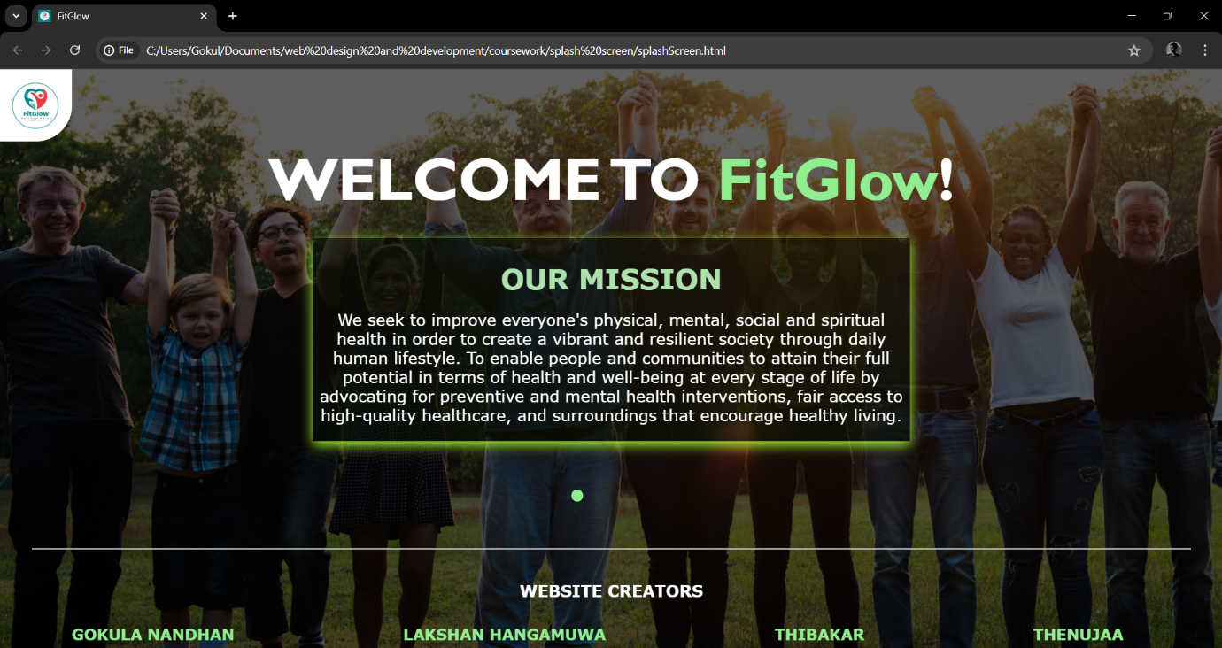

* shop.html

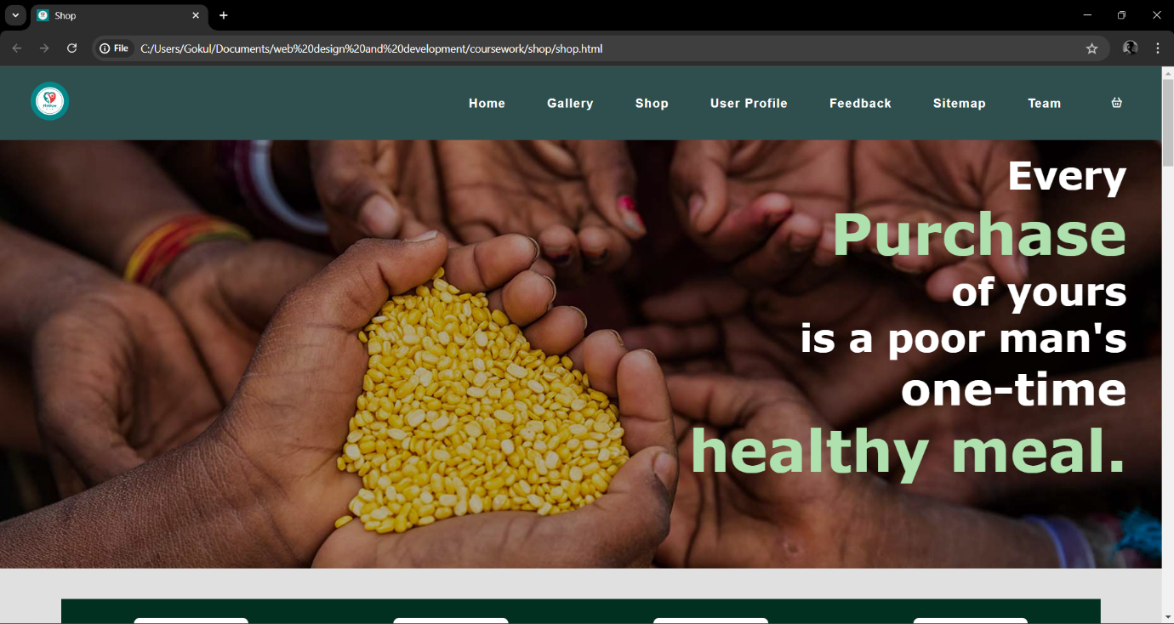

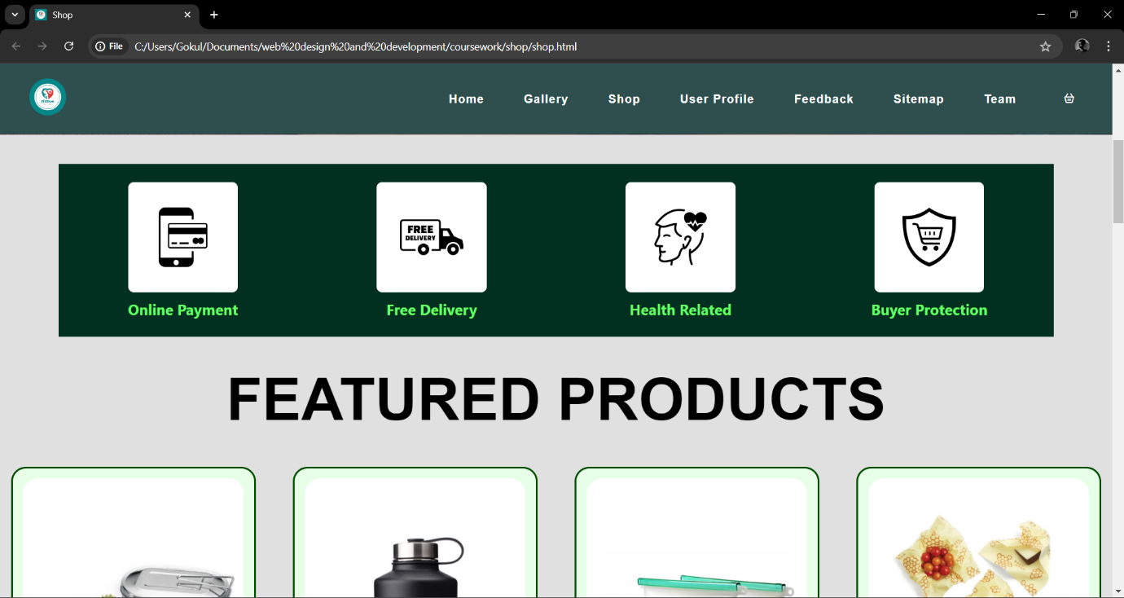

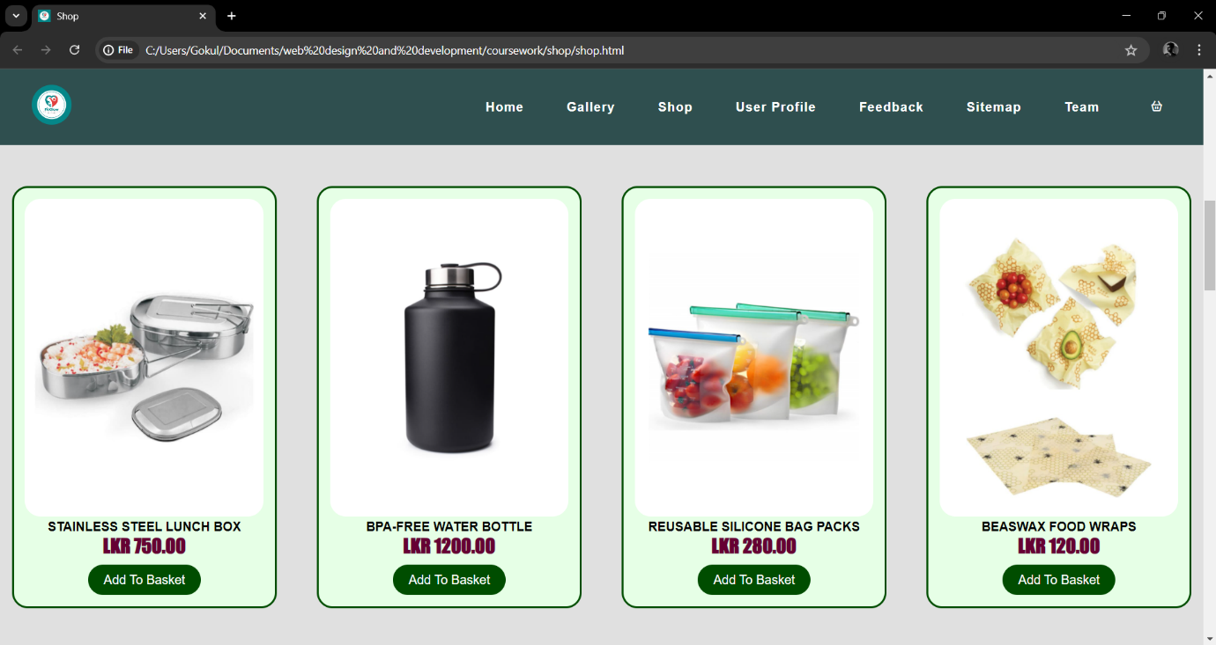

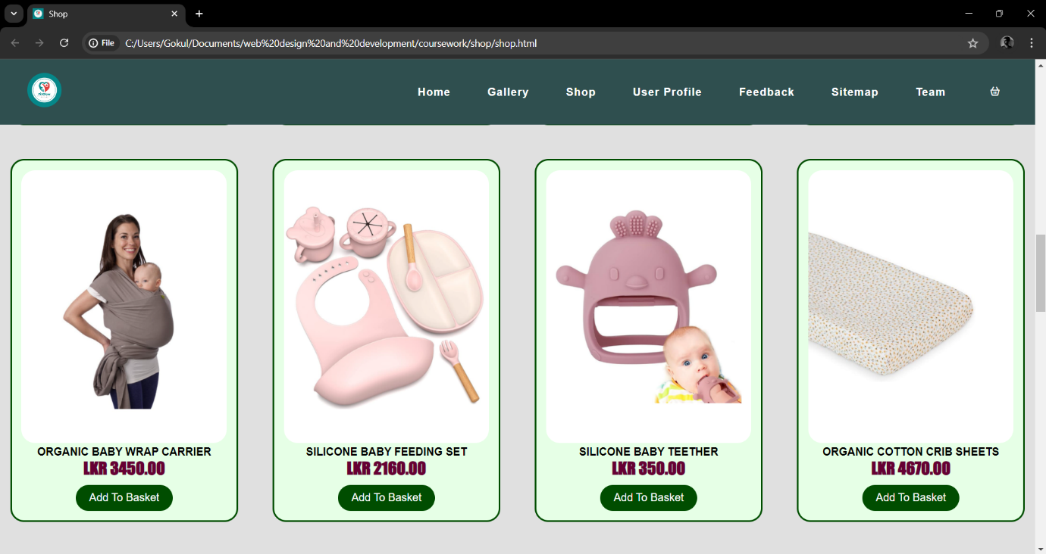

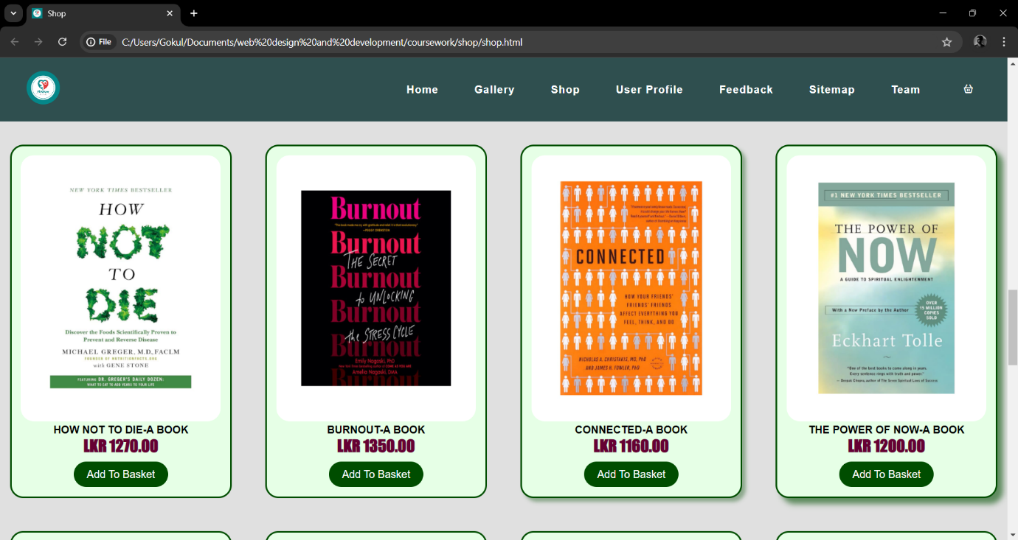

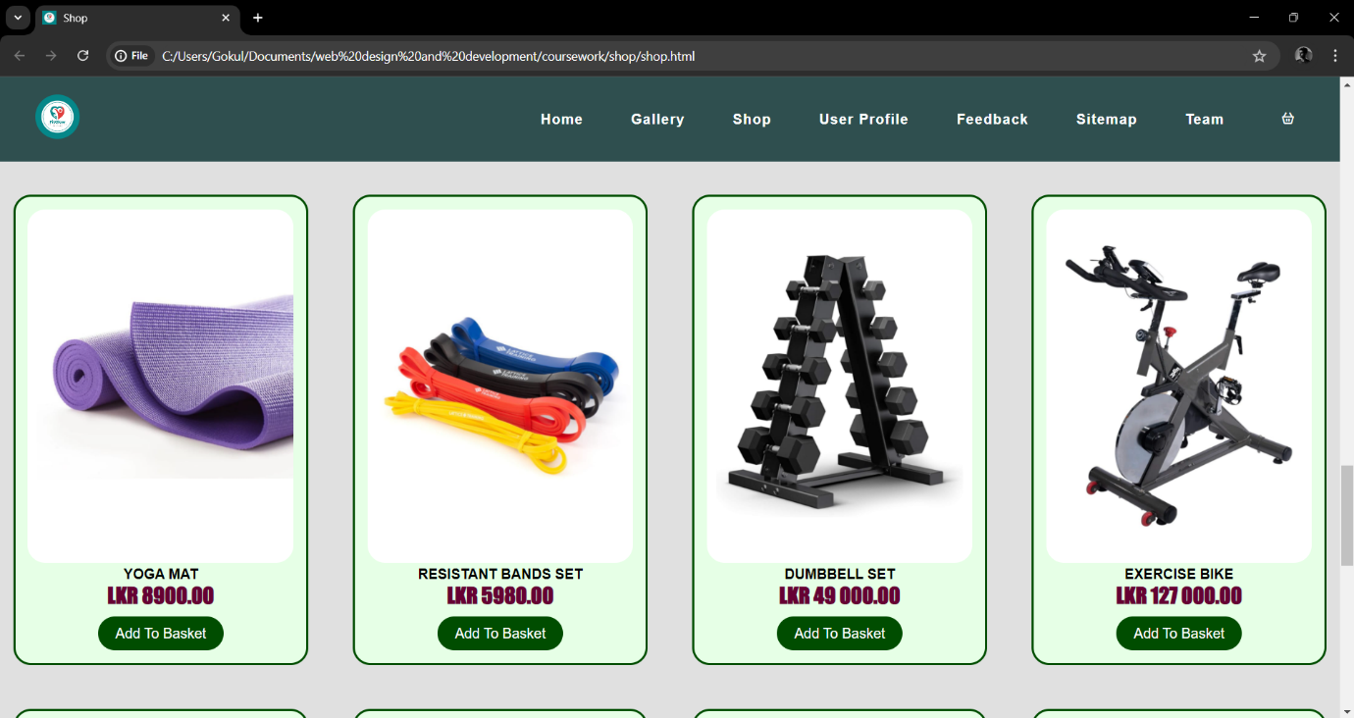

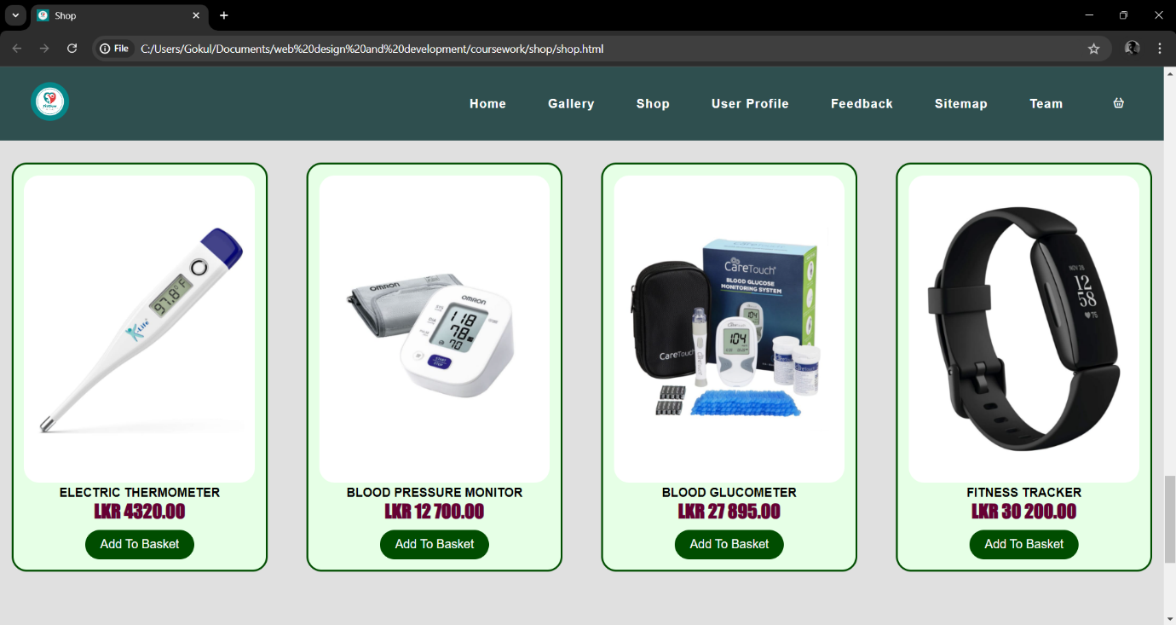

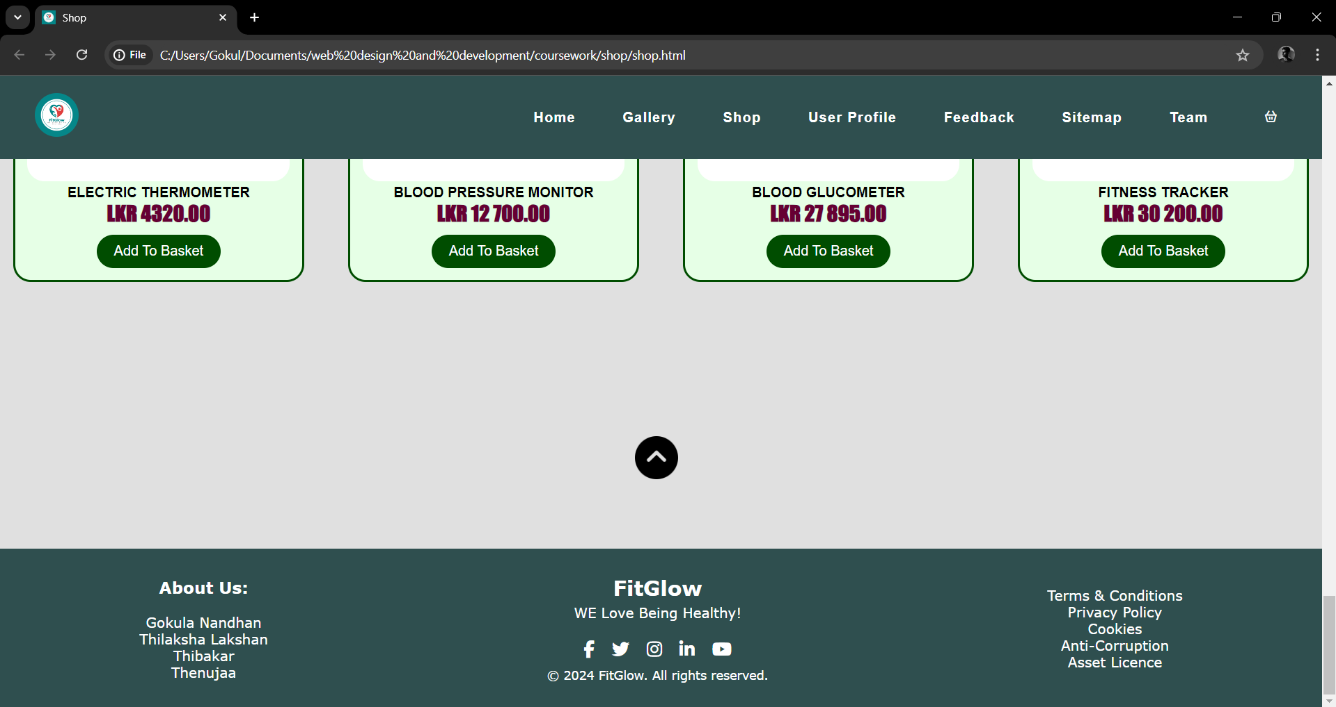

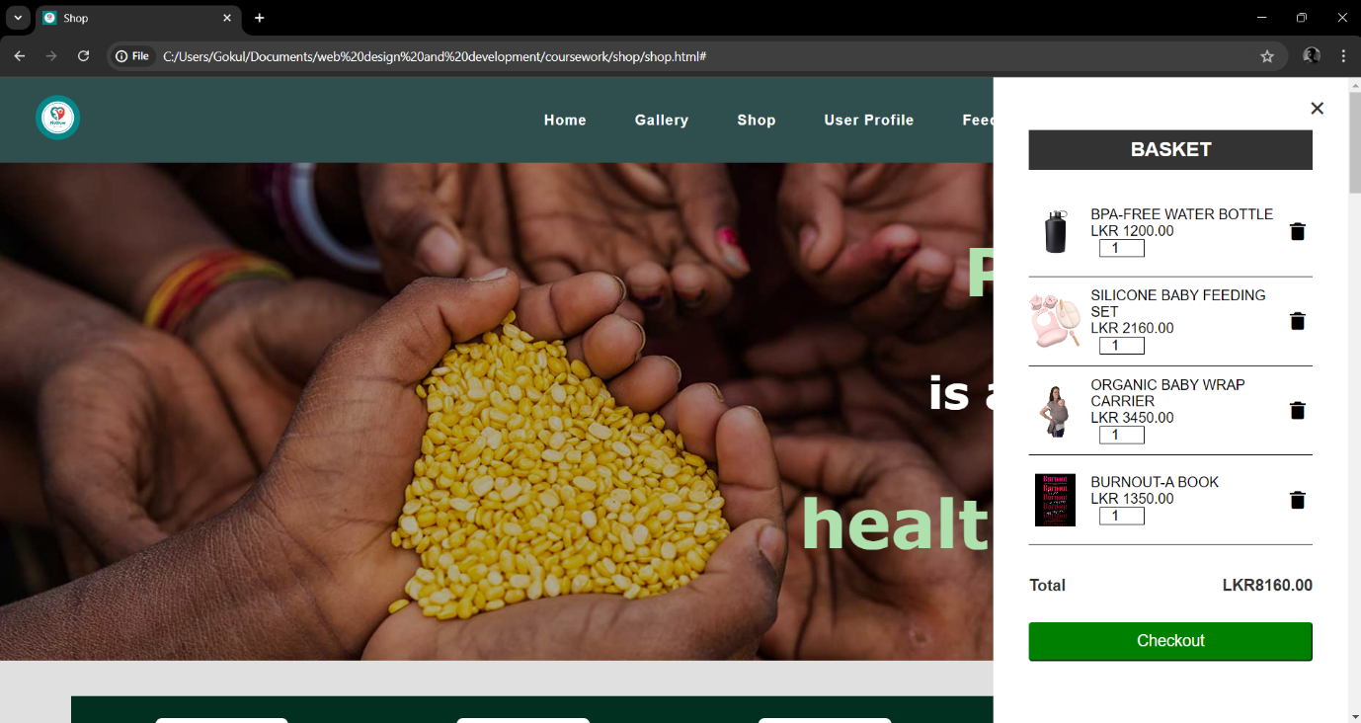

* checkout.html

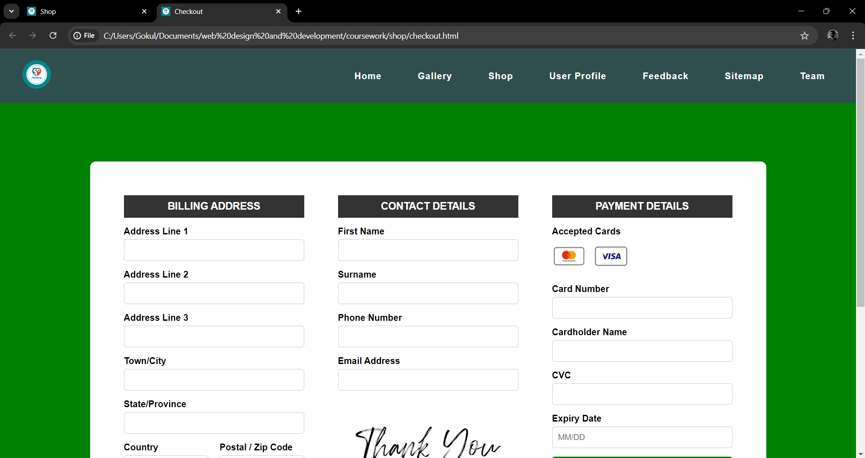

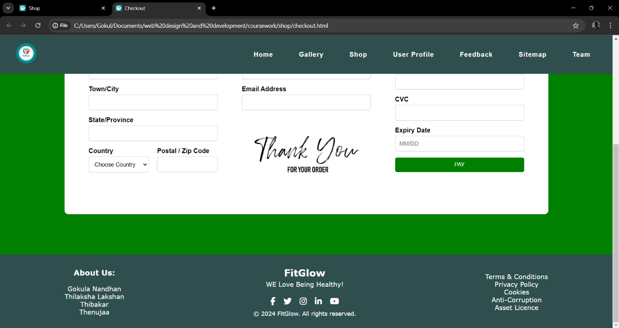

* pageeditor.html

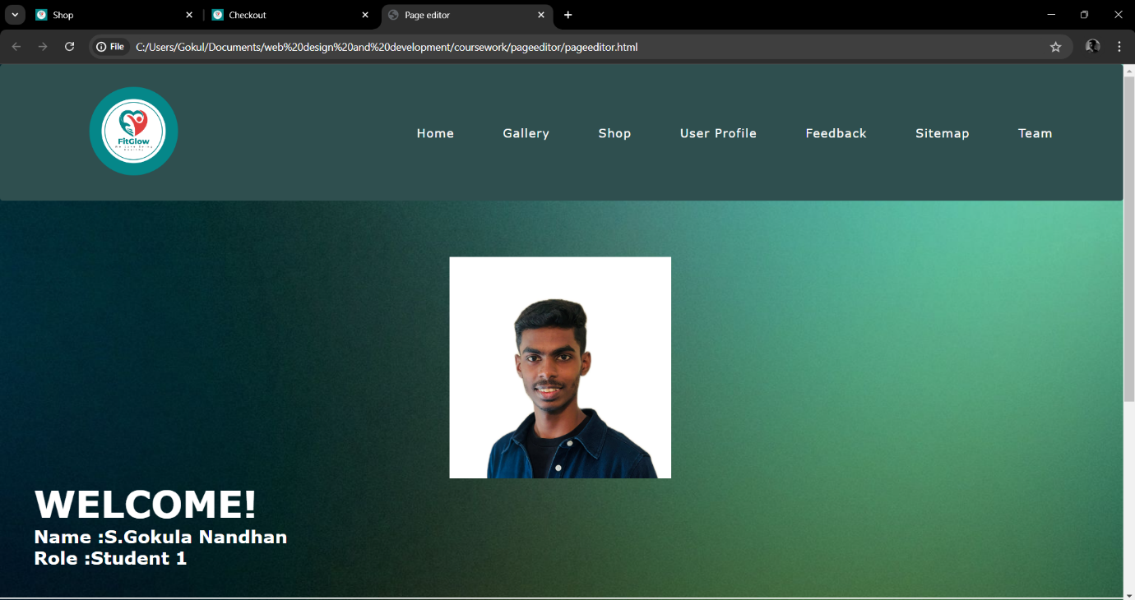

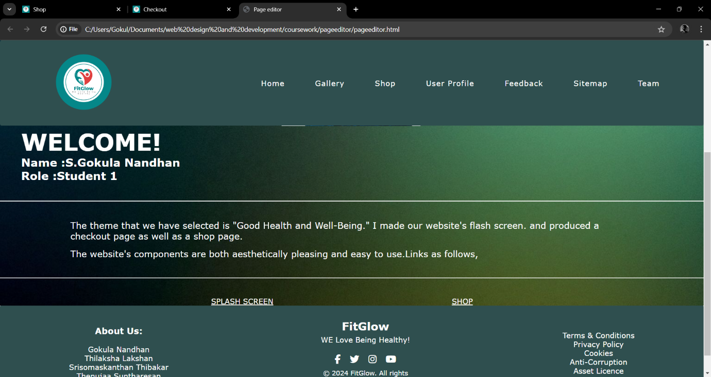

* contentpage.html

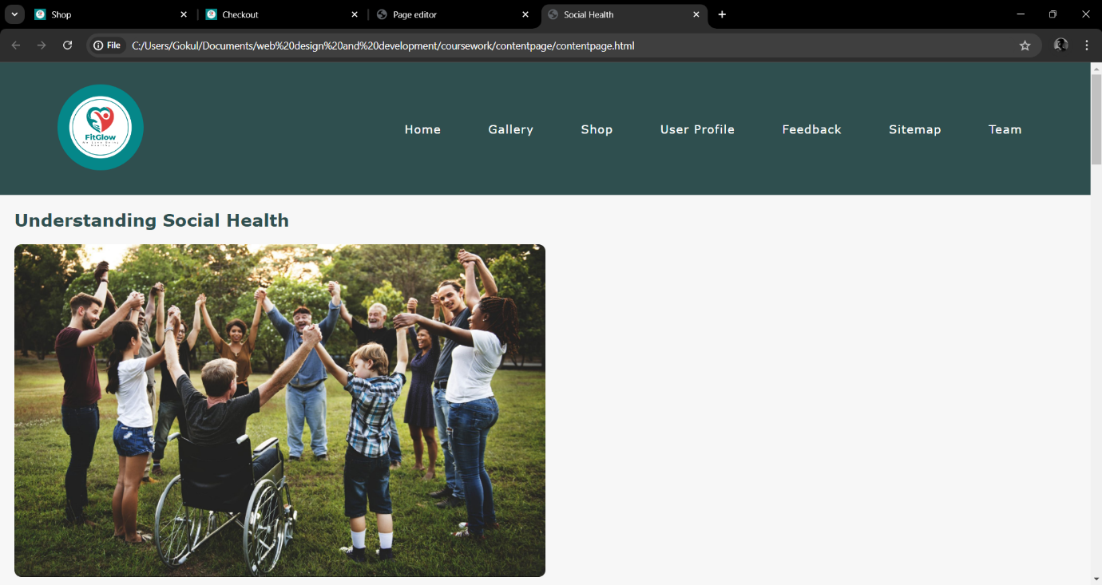

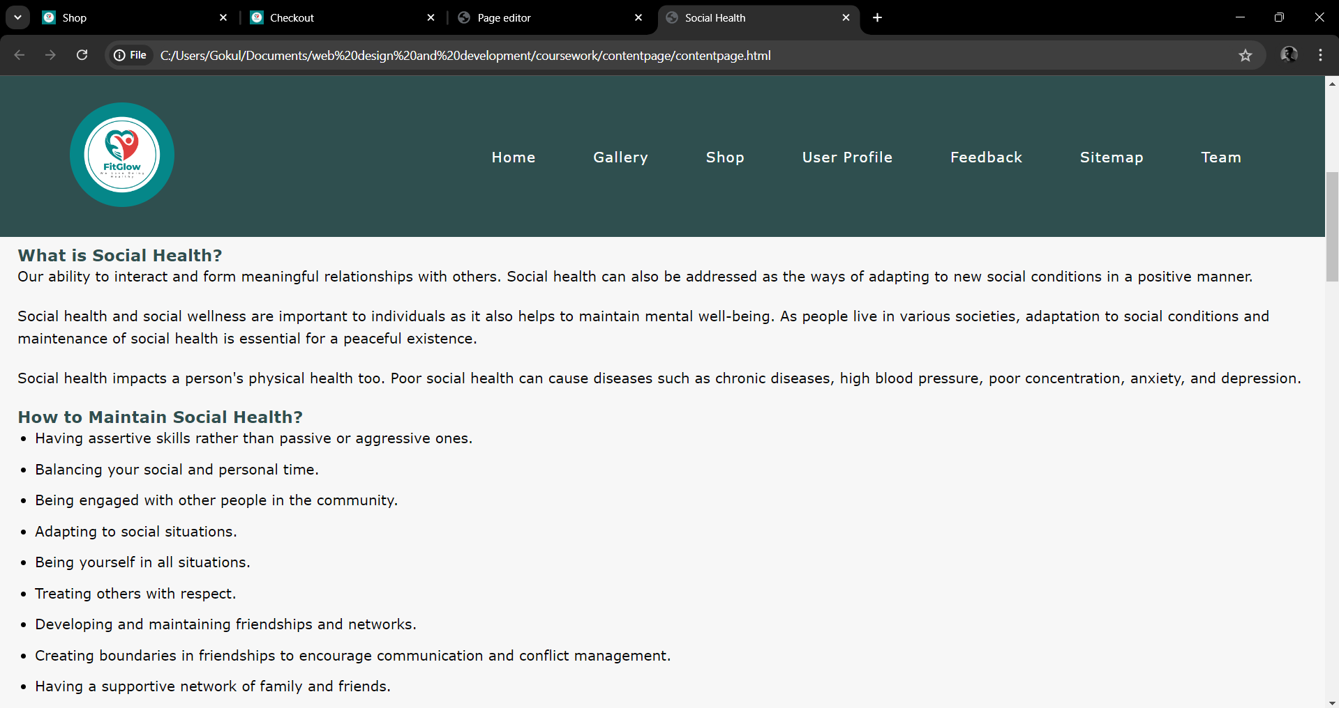

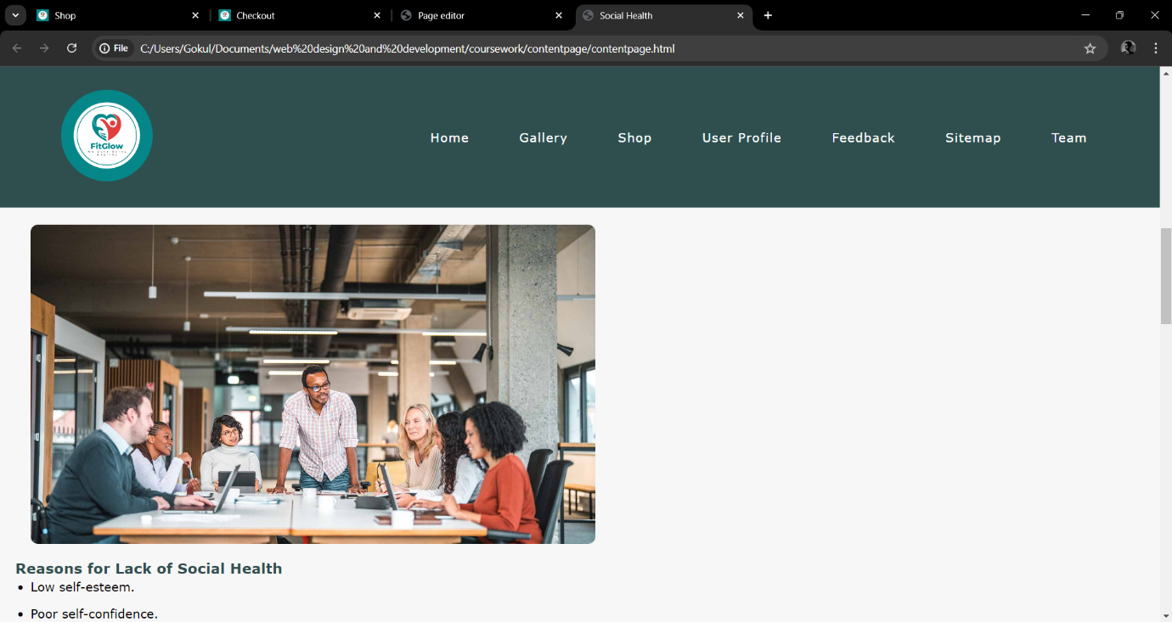

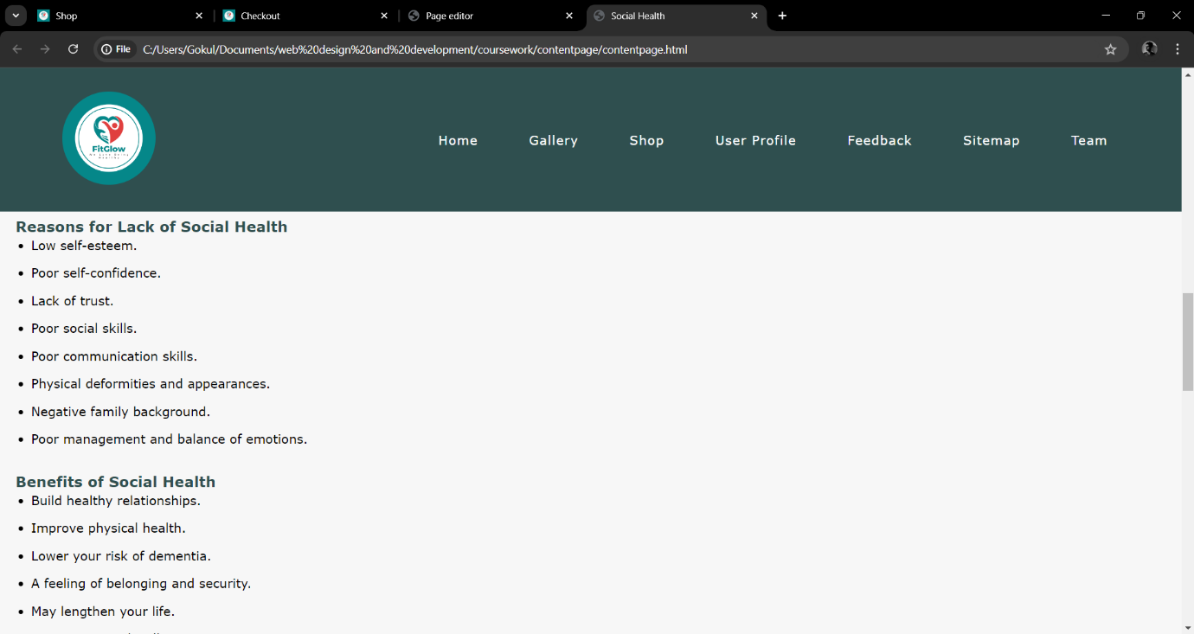

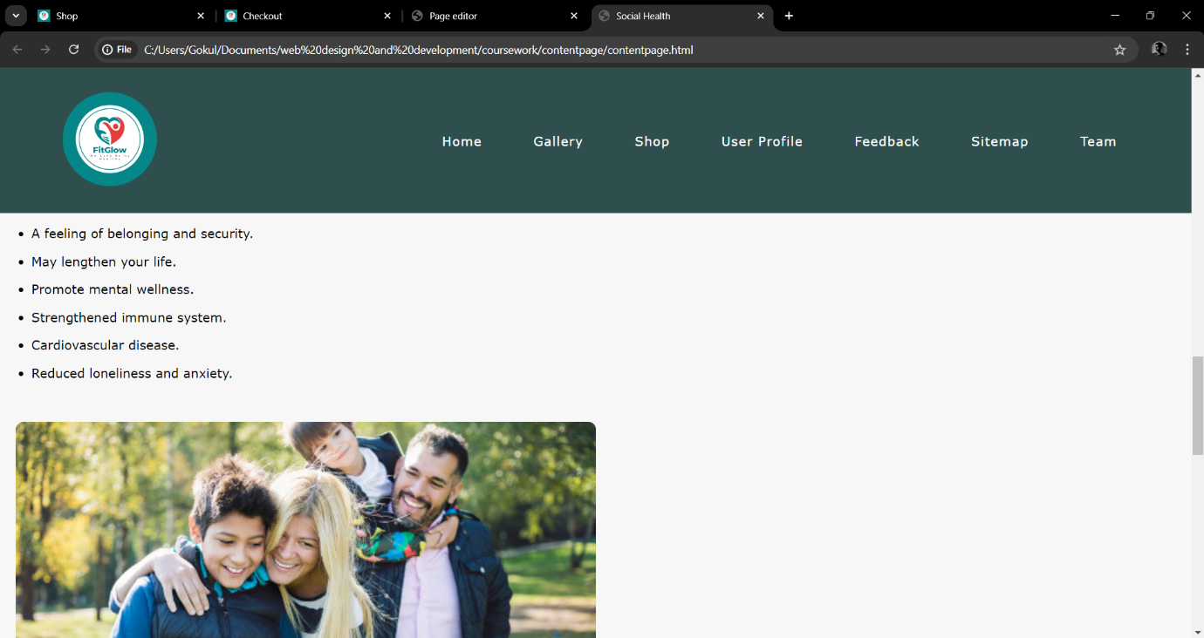

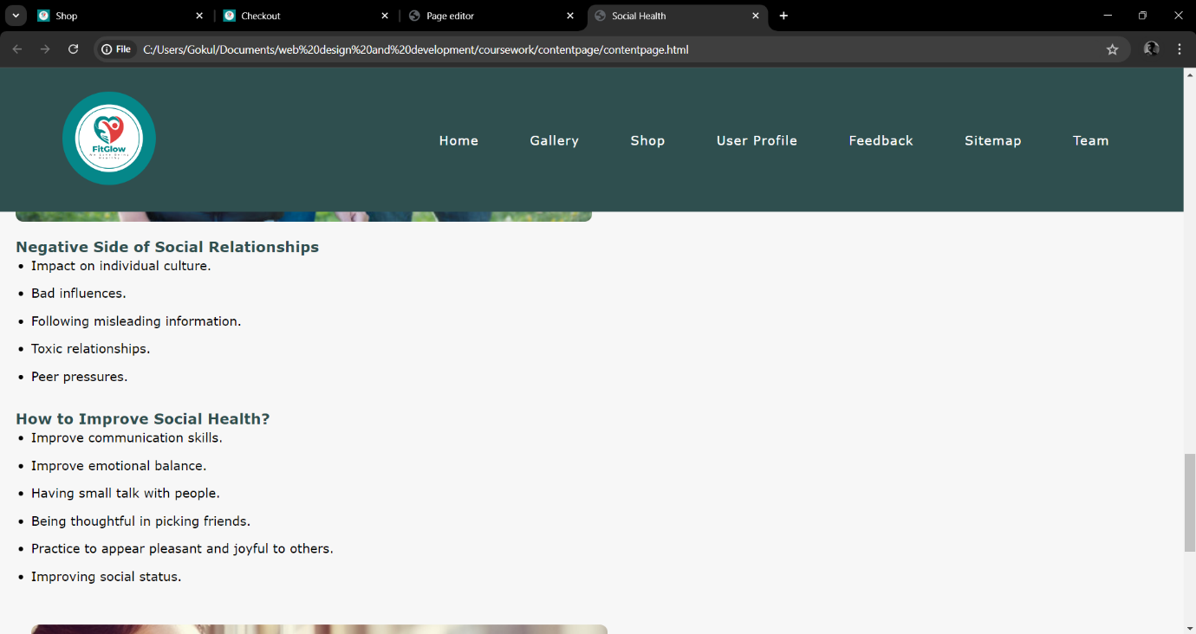

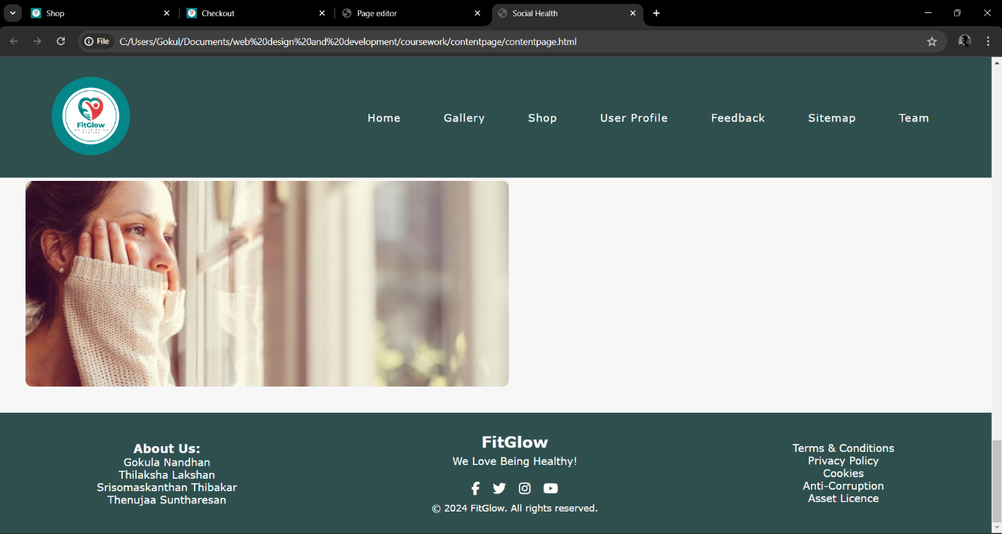

## contentpage.css Appendix C: Screenshots - Webpage Validation Evidence

* checkout.html

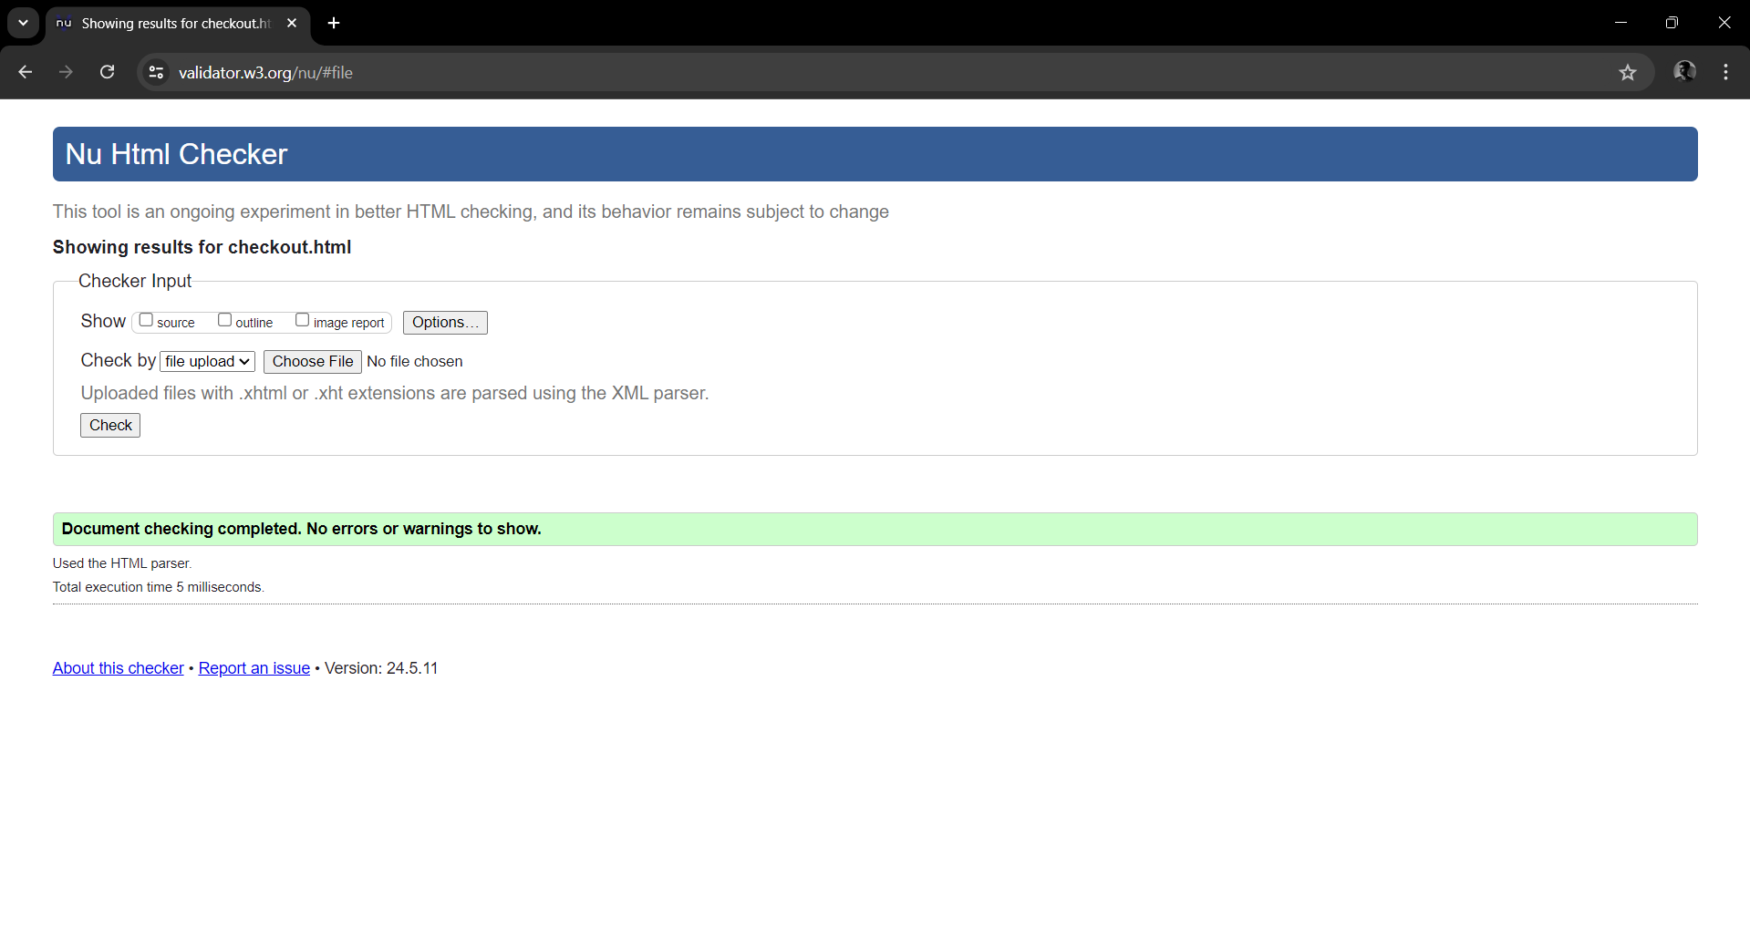

* shop.css

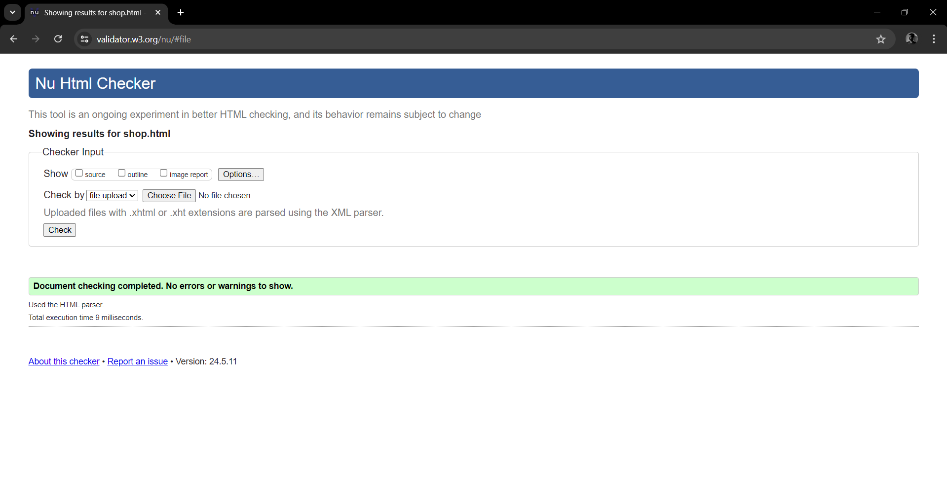

* splashScreen.html

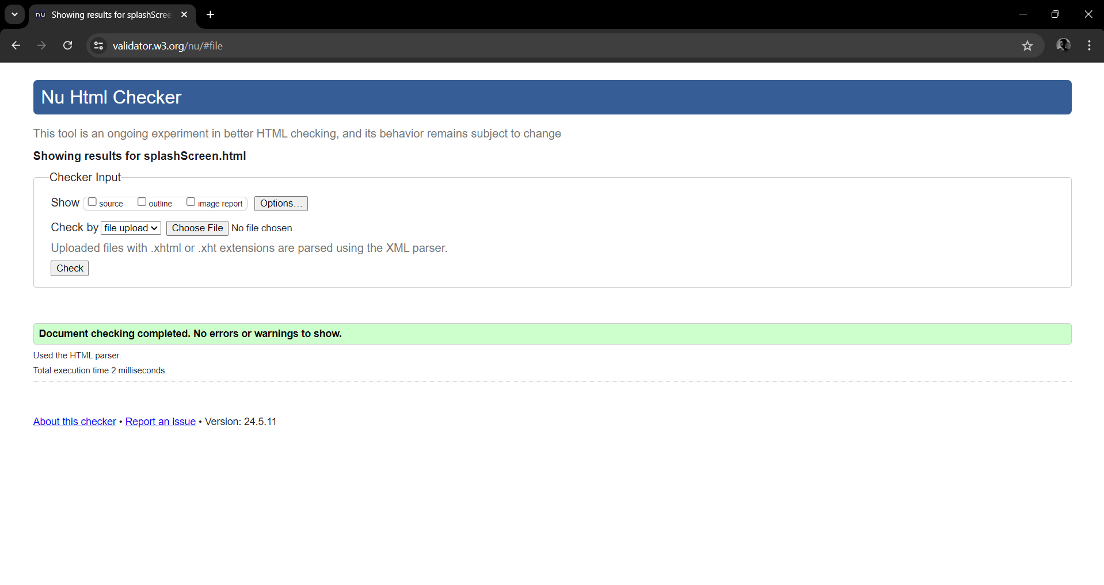

* contentpage.html

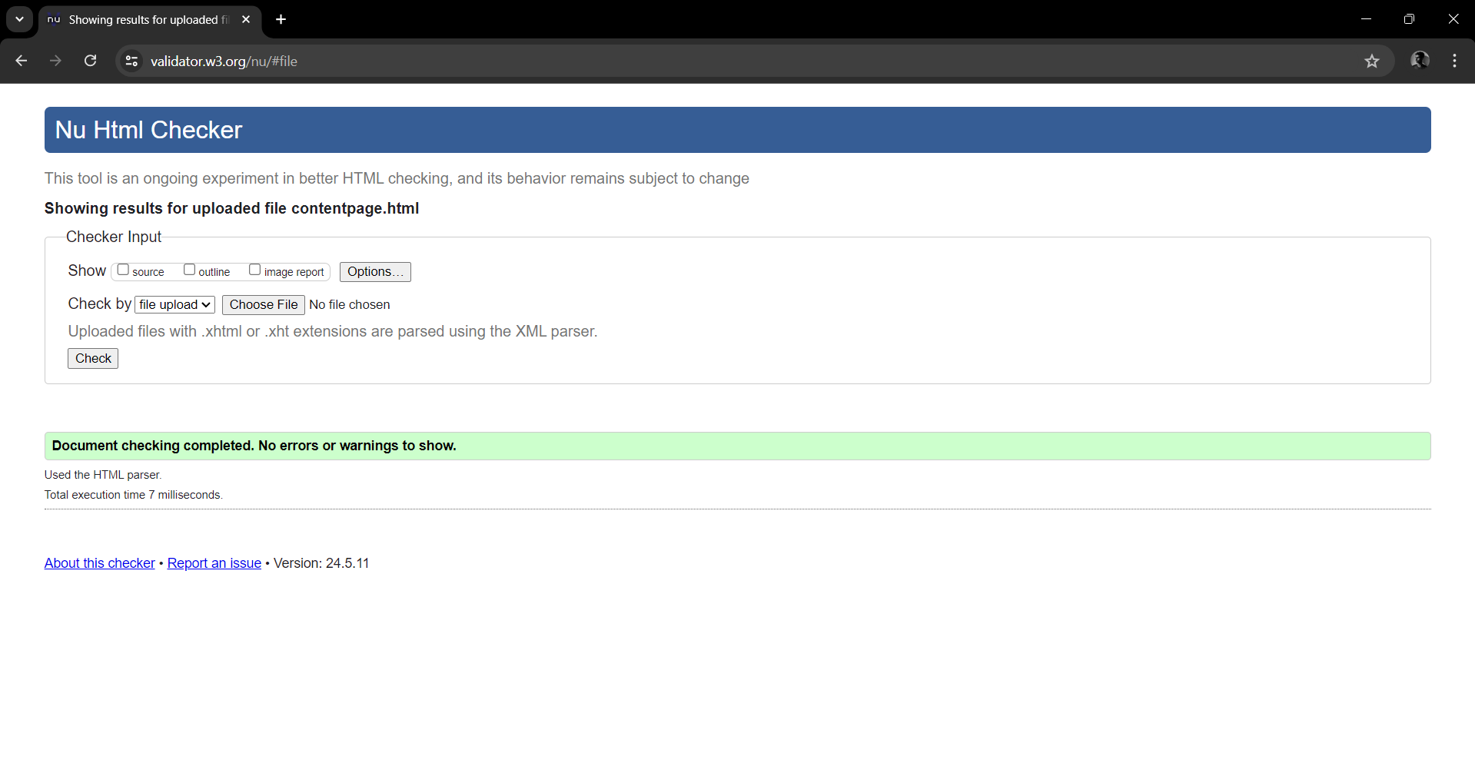

* pageeditor.html

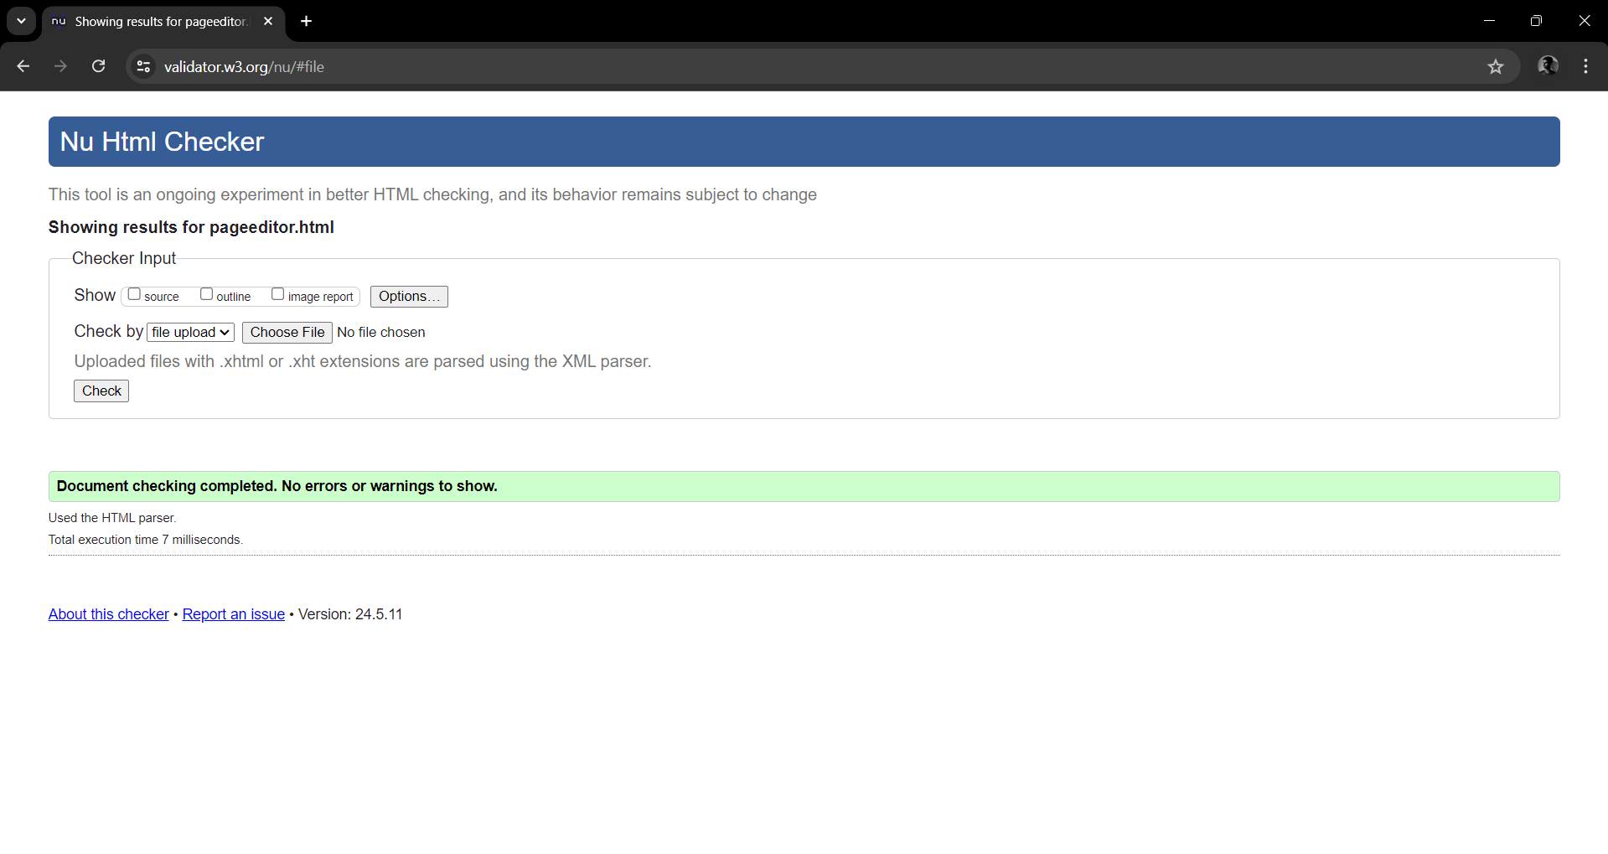

## 

## Appendix D: Task Completion Checklist

|  |  |  |  |  |
| --- | --- | --- | --- | --- |
| **Student 1 Tasks** | **Completed** | | | **Student Comments** |
| **Yes** | **No** | **Partially** |
| 1 – Splash Screen | **Yes** |  |  | **Successfully worked** |
| 2 – Shop | **Yes** |  |  | **Perfectly works** |
| 3 – Content page | **Yes** |  |  | **Good** |
| 4 – Page Editor | **Yes** |  |  | **Good** |
| 5 – Use of the provided navigation bar (adapted) | **Yes** |  |  | **Used properly** |
| 6 – Use of provided template (adapted) | **Yes** |  |  | **Used provided templates** |
| 7 – Additional CSS | **Yes** |  |  | **Added** |
| 8 – Additional Interactivity | **Yes** |  |  | **Working correctly** |
| 9 – Uploaded to Webserver |  | **No** |  |  |